**Anova:**

**Analysis of variance**

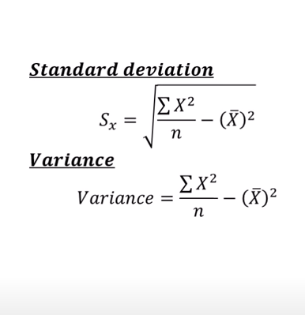

**Correlation coefficient**

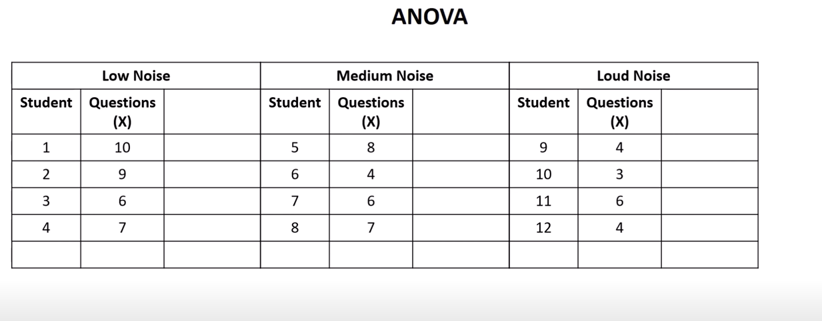

**Relation between noice and no of question solved**

**Noise increases no of questions decreases**

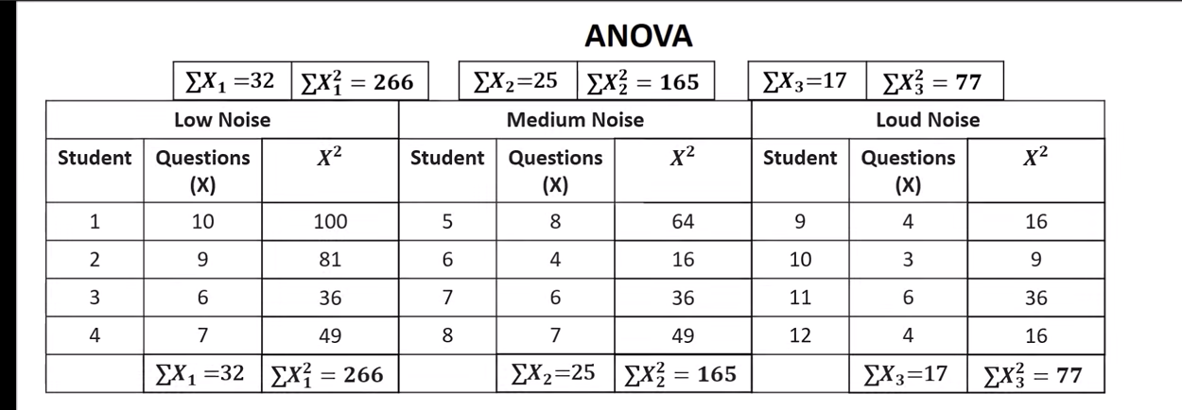

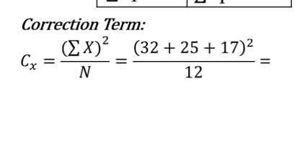

**N= no of students**

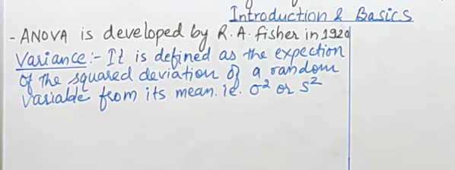

**T test: two populations**

**Anova: more than 2 population or population who has more than 2 groups**

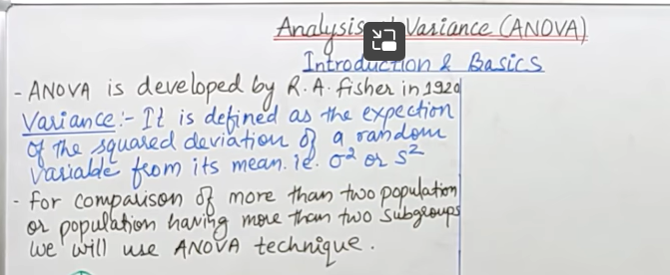

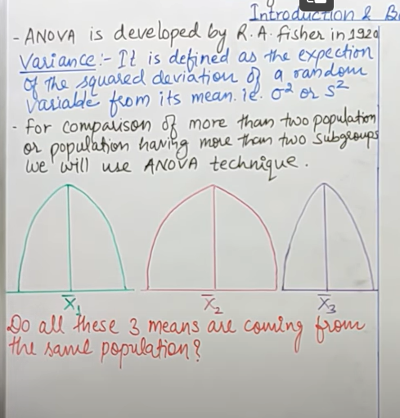

**Within large population we need to draw small populations**

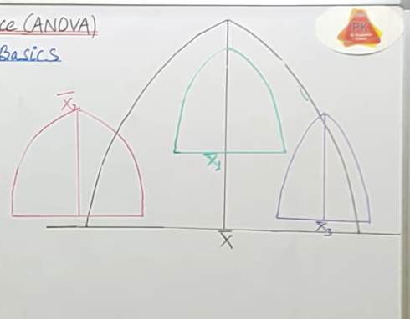

**These means of sample may be close or far to each other that depends on arrangement in population**

**Middle sample mean is close to population mean**

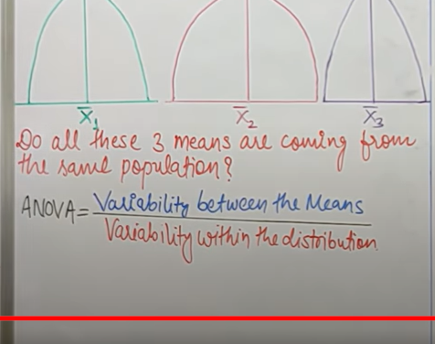

**Variability between the means: distance between all sample mean to population means**

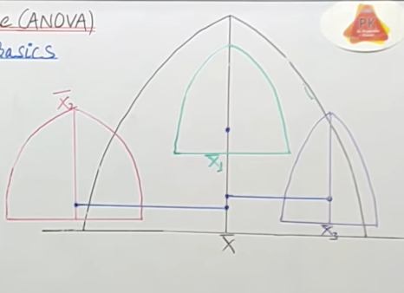

**Variability within the distribution:**

**Red lines**

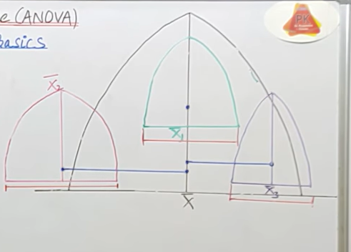

**Variability of 1st sample plus variability of second….**

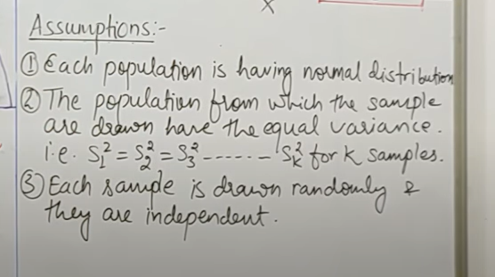



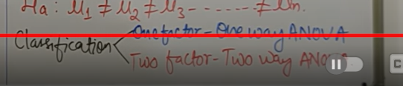

**One way**

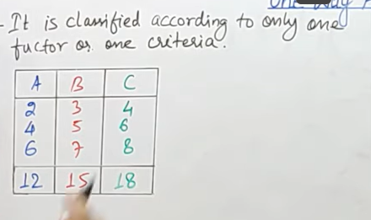

**A,b,c are samples**

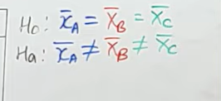

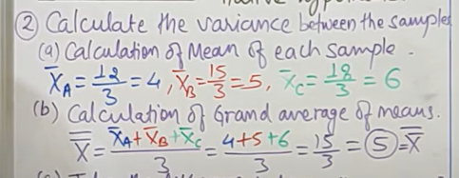

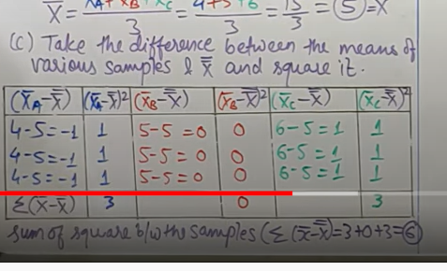

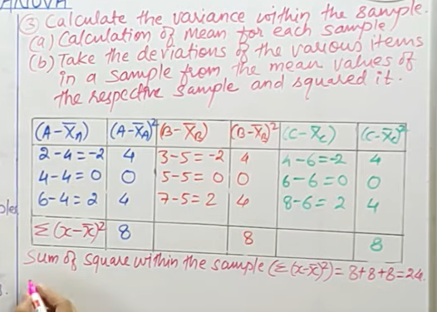

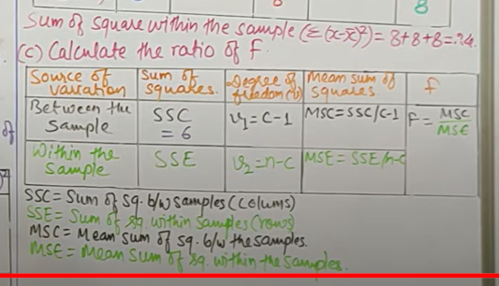

**C= no of columns**

**N= no of observations**

**3 columns and 3 rows**

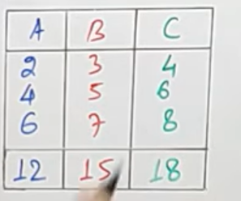

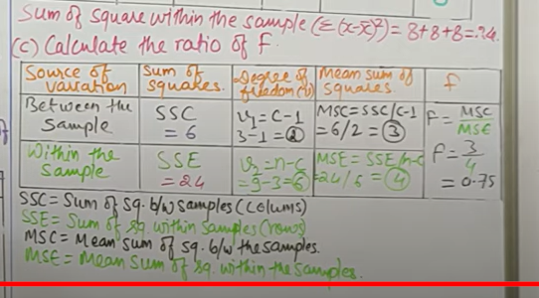

**Chisquare-**

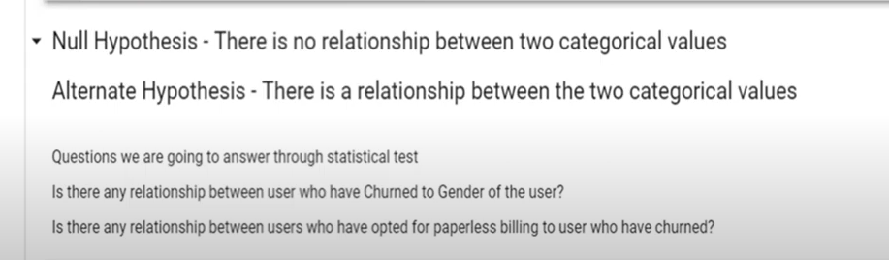

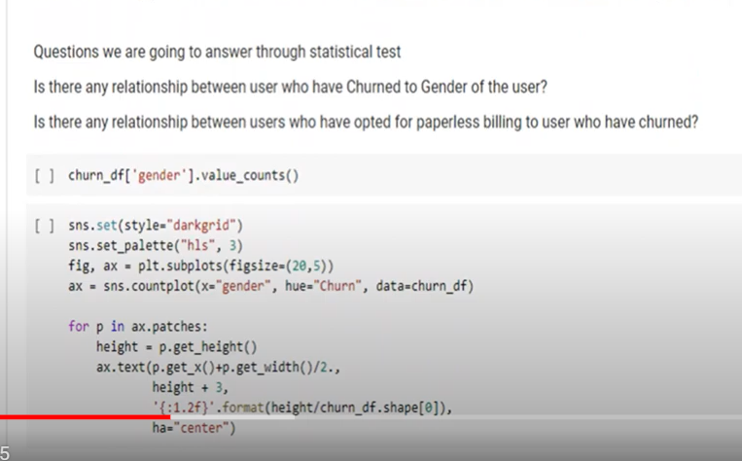

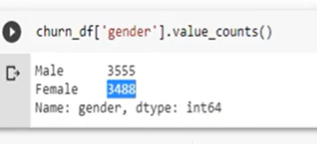

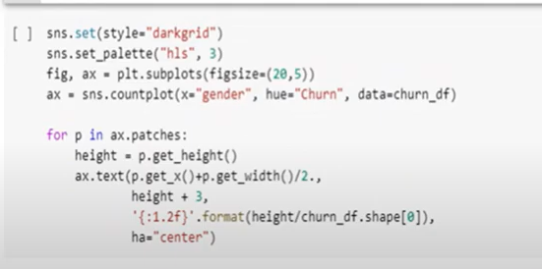

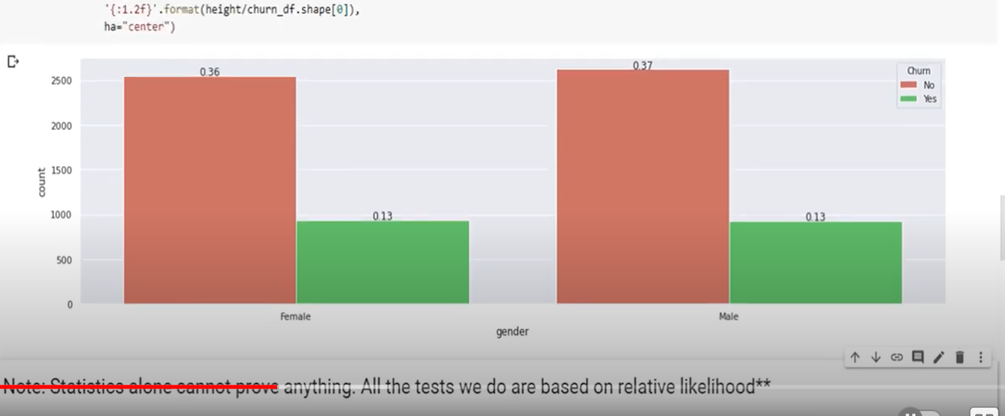

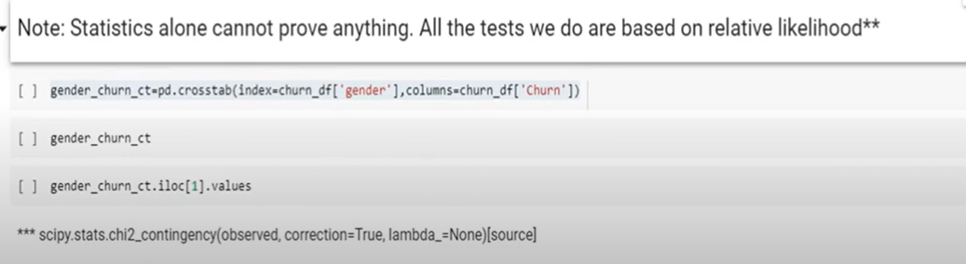

**For chi square: we need to perform contingency table(cross tab)**

**Contingency table: used to summarize relationship between several categorical value**

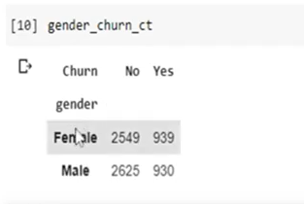

**Contingency table compare categorical values**

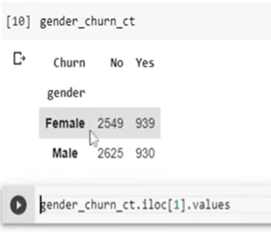

**Chi square test of independence**

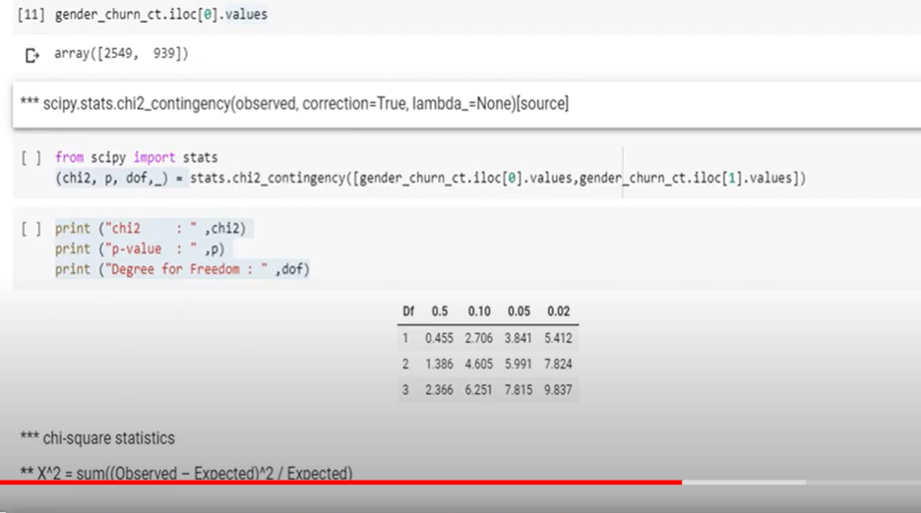

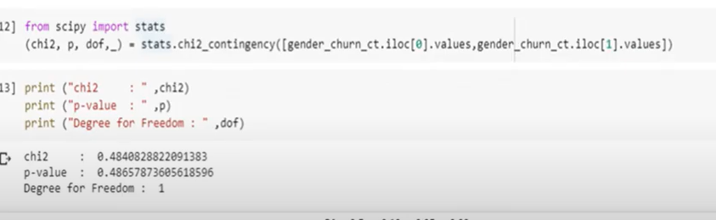

**0.48--- not significant**

**Near to 1 is significance**

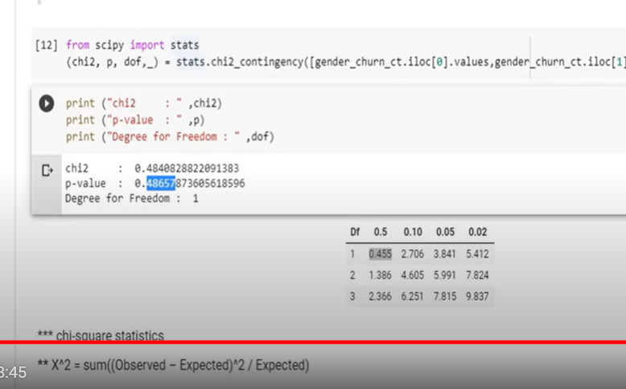

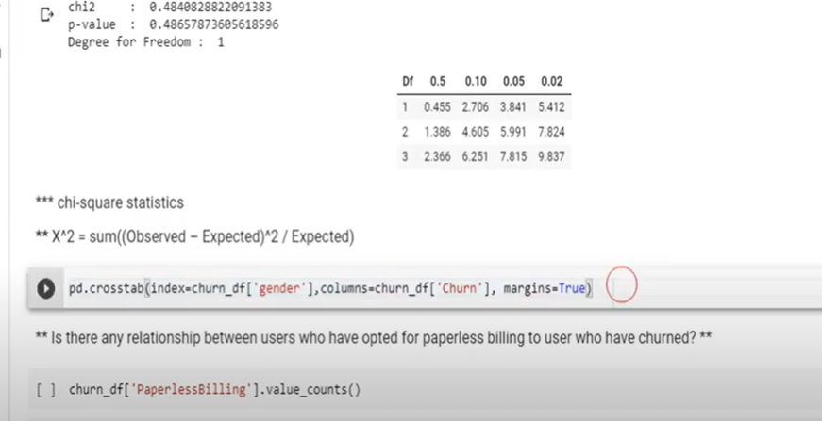

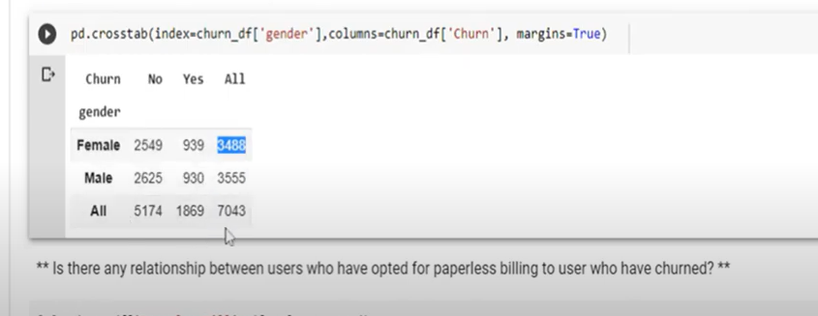

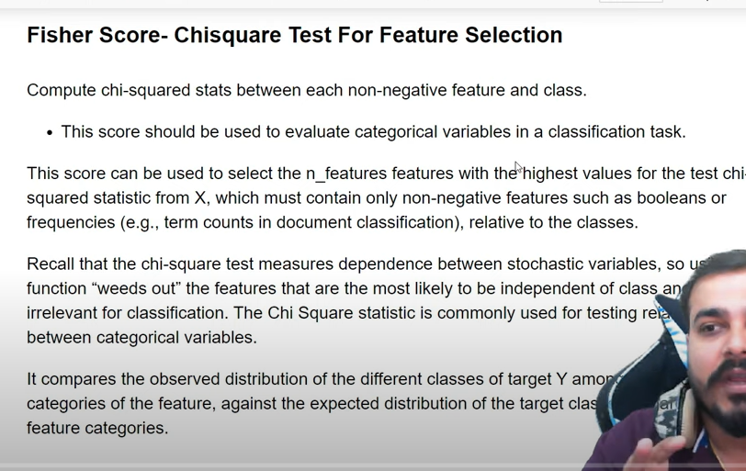

**First one hot encoding**

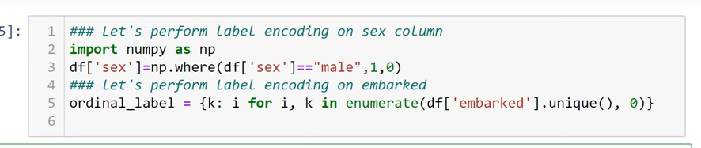

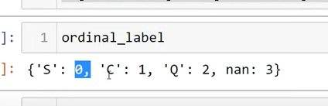

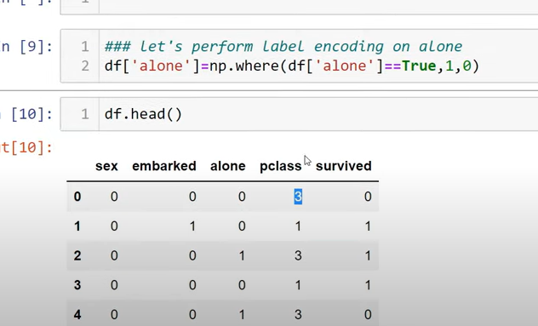

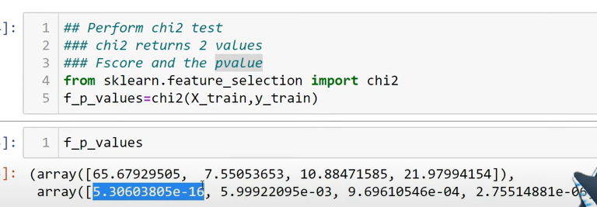

**Lower the p value : imp is feature**

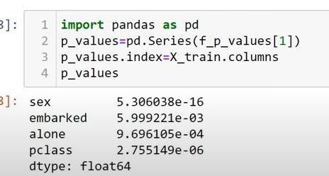

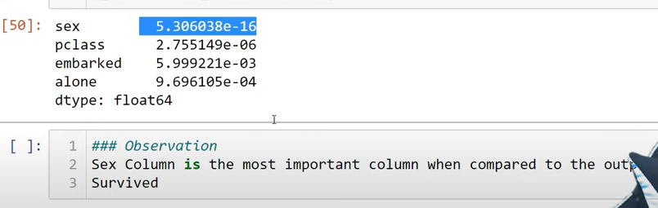

**Parametric vs non parametric test**



**99 percent chi square is non parametric, -But when we are testing variance it can be parametric**

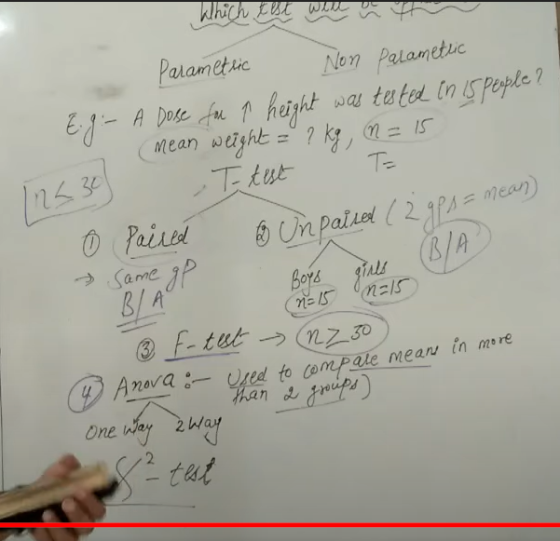

**Chi -square:**

**Observed and expected frequency**

**P value considered/0.5 0r 0.1**

**5 percent deviation or risk which he would like to take**

**Degree of freedom = n-1**

**2 types of chisquare:**

**Test of independence(d.f= (row-1)(column-1)**

**Test of goodness of fit(d.f= n-1**

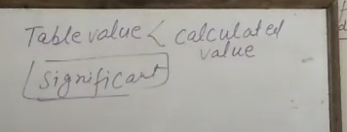

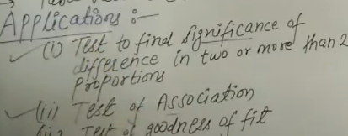

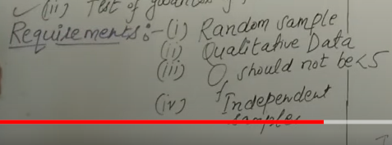

**Sample size atleast 5**

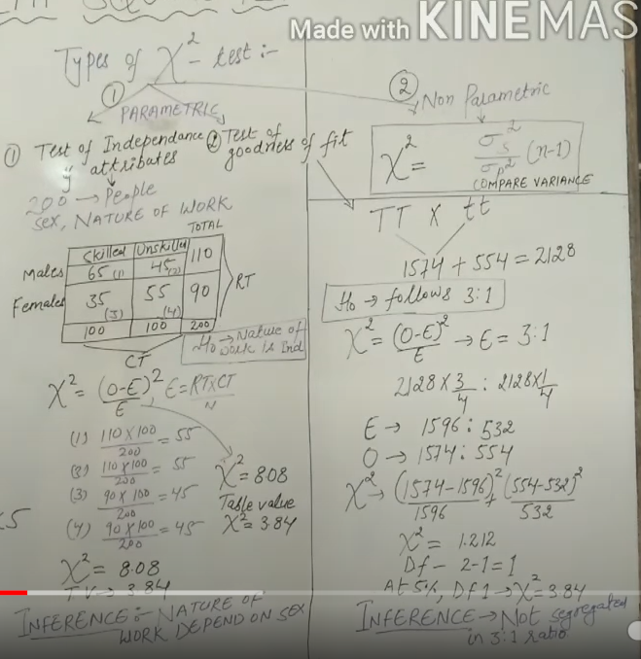

**In test of independence**

**Nature of work is independent = null**

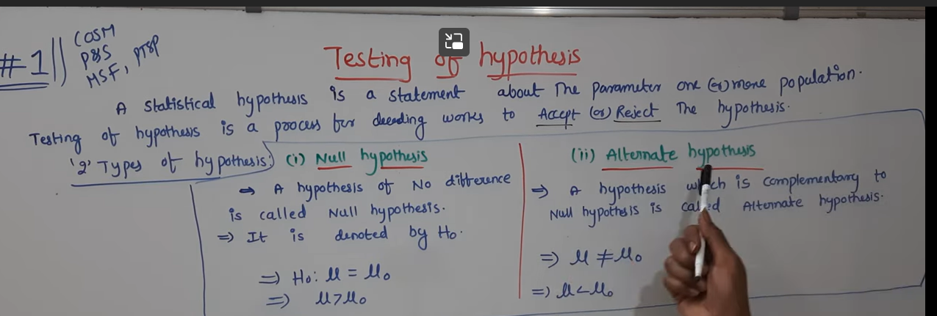

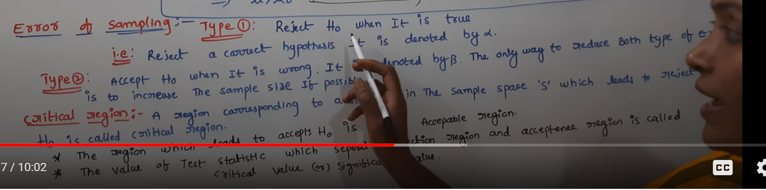

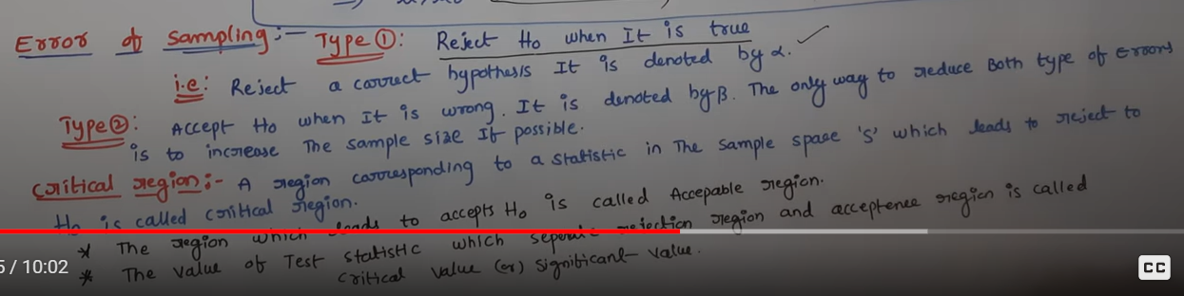

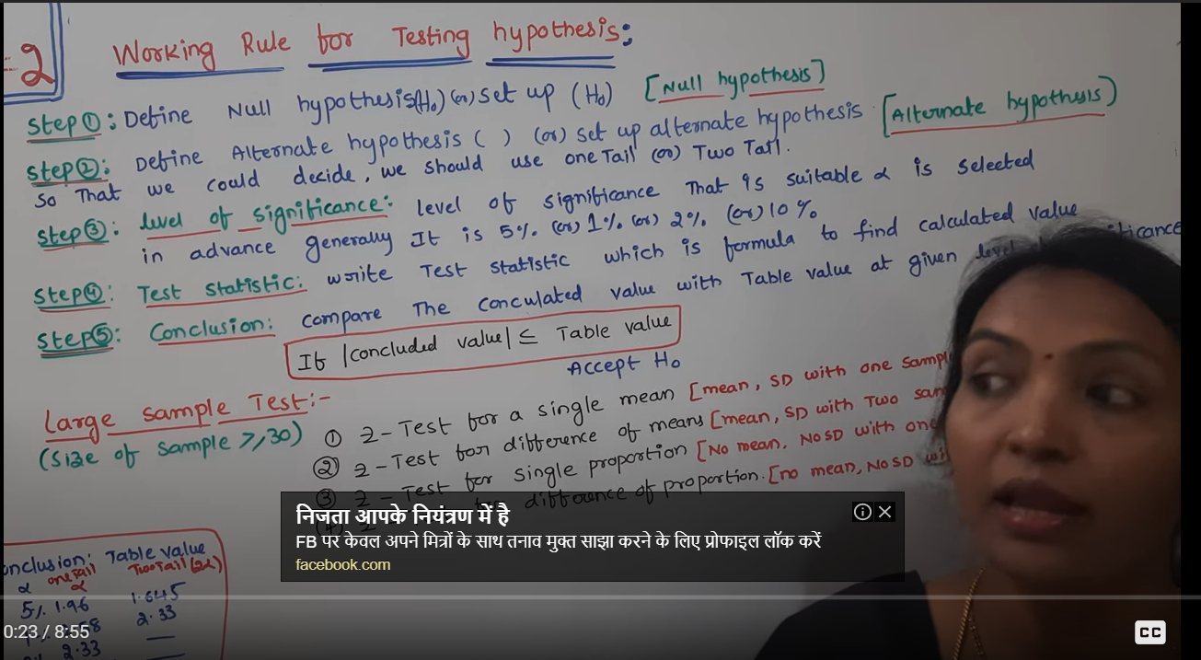

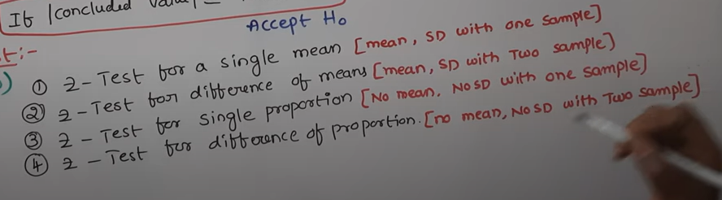

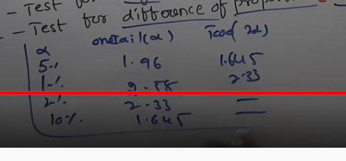

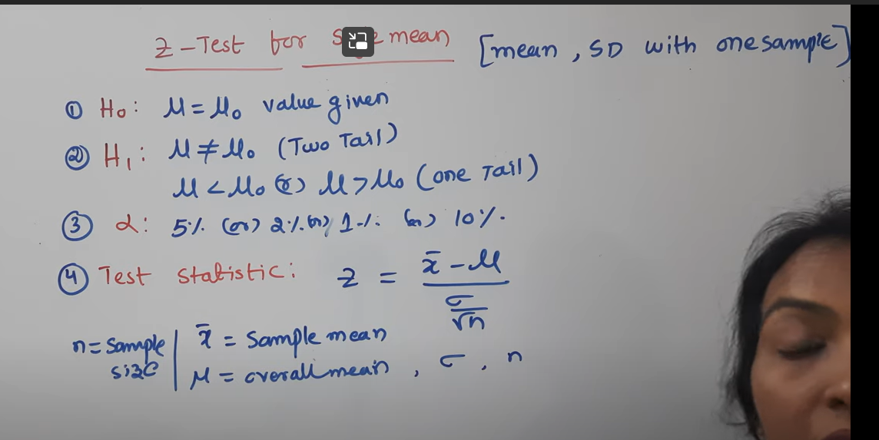

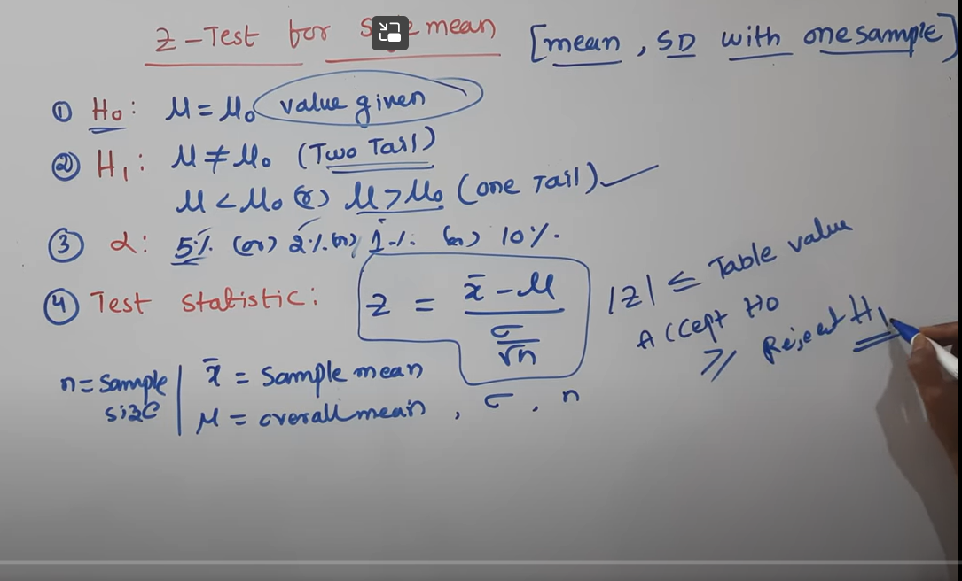

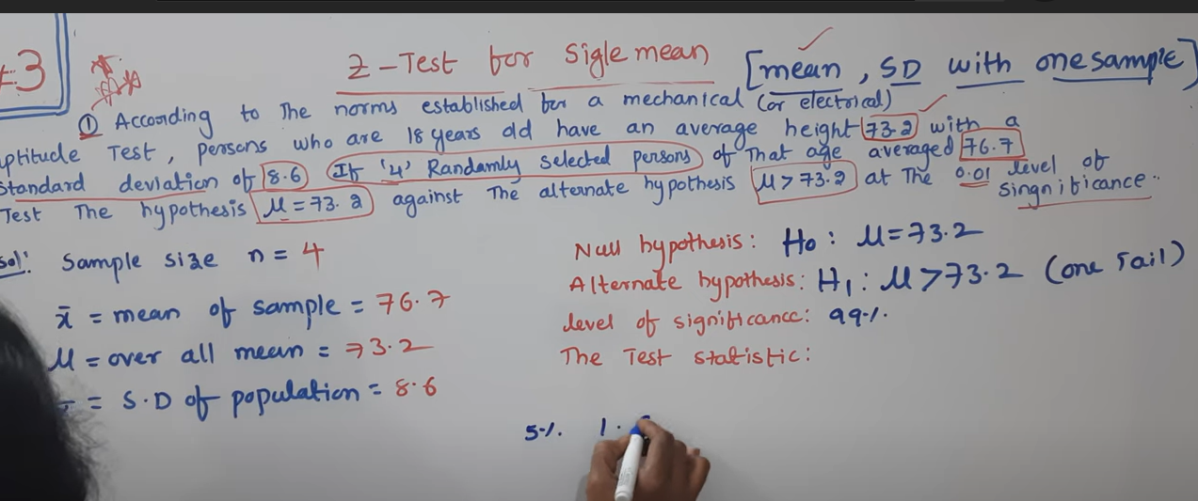

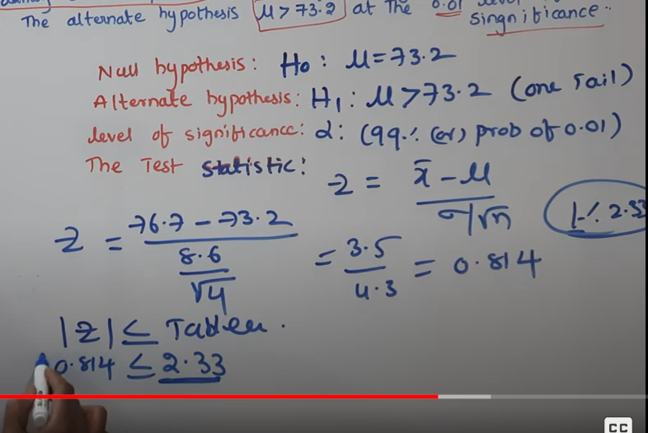

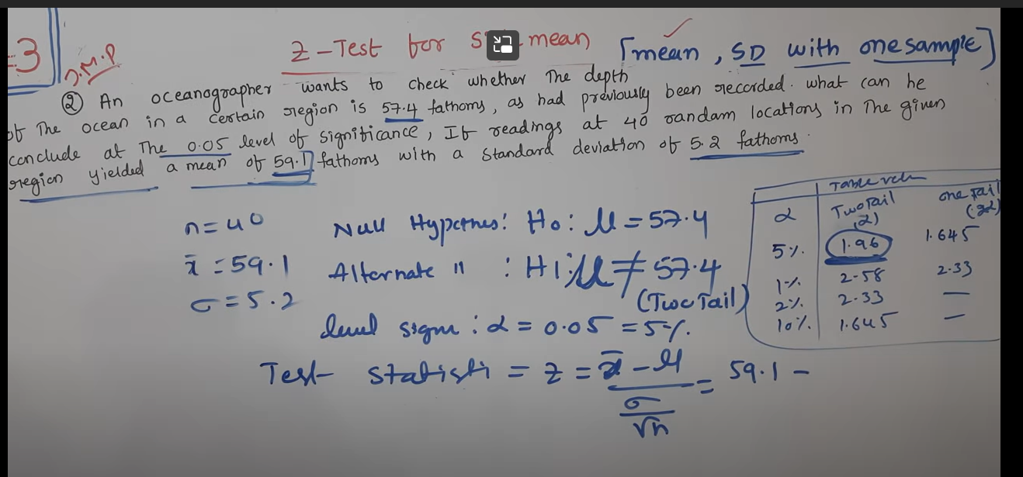

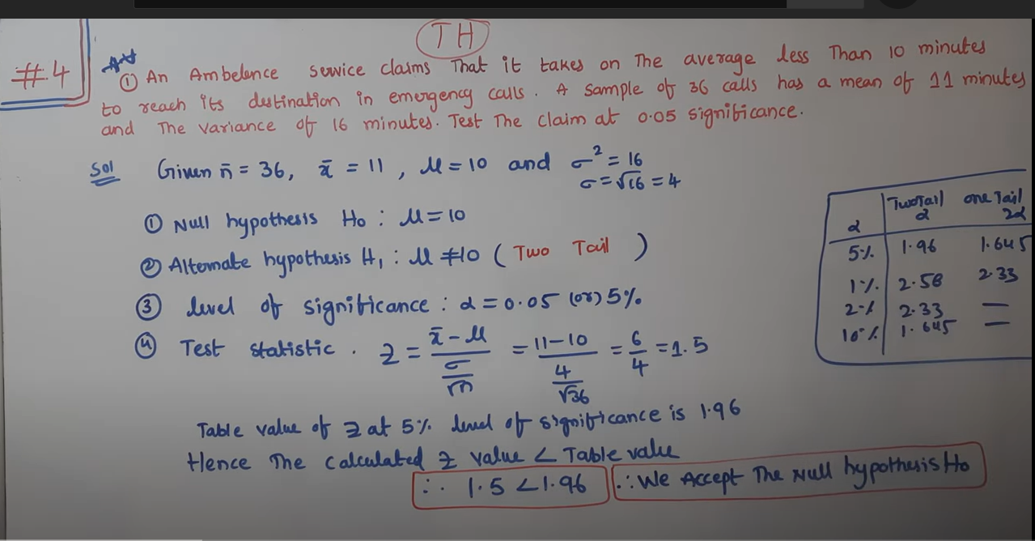

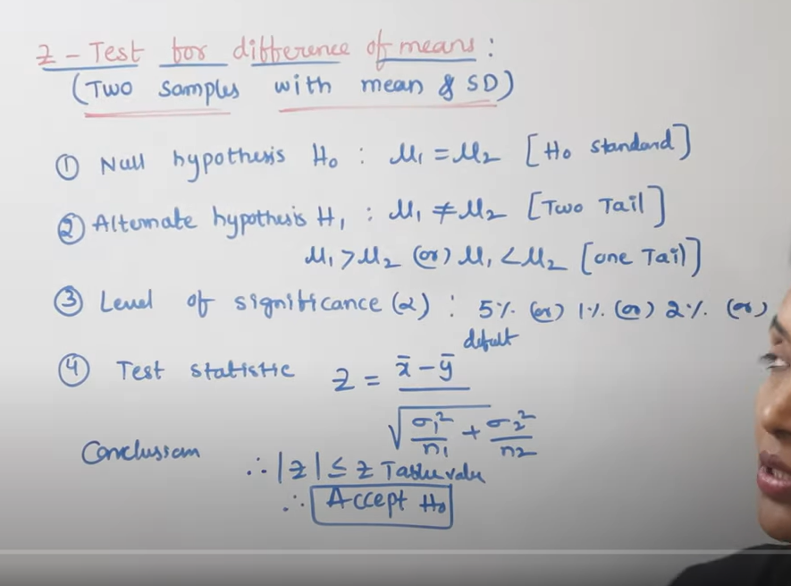

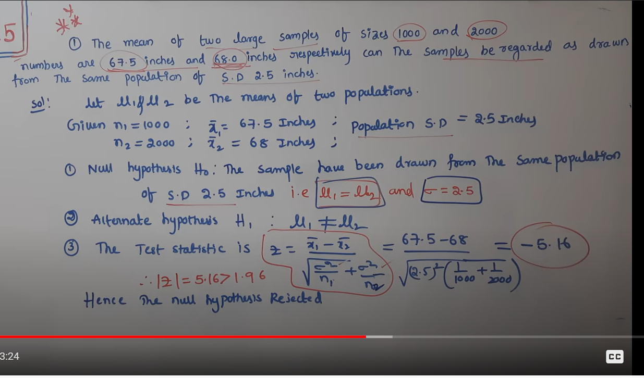

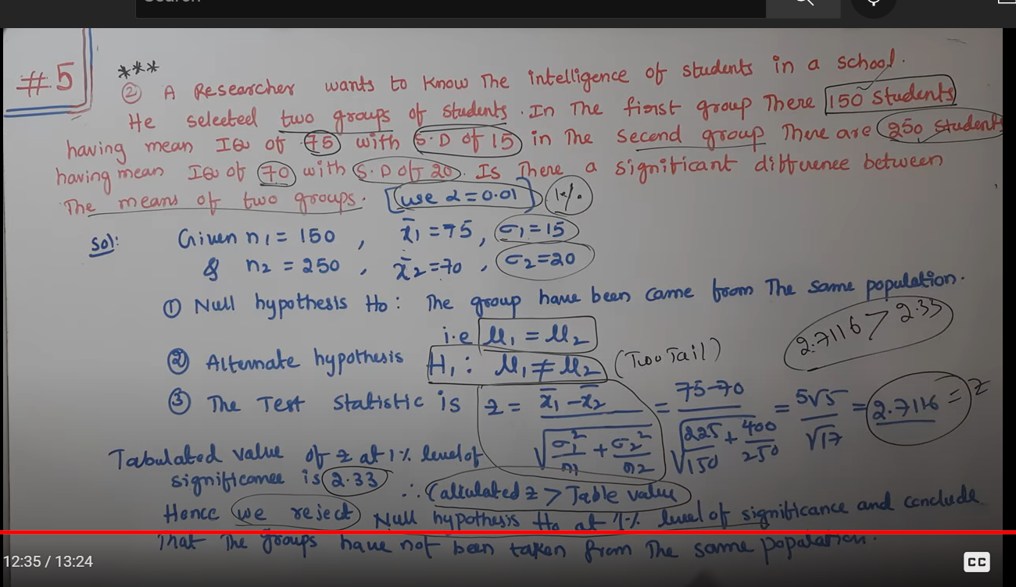

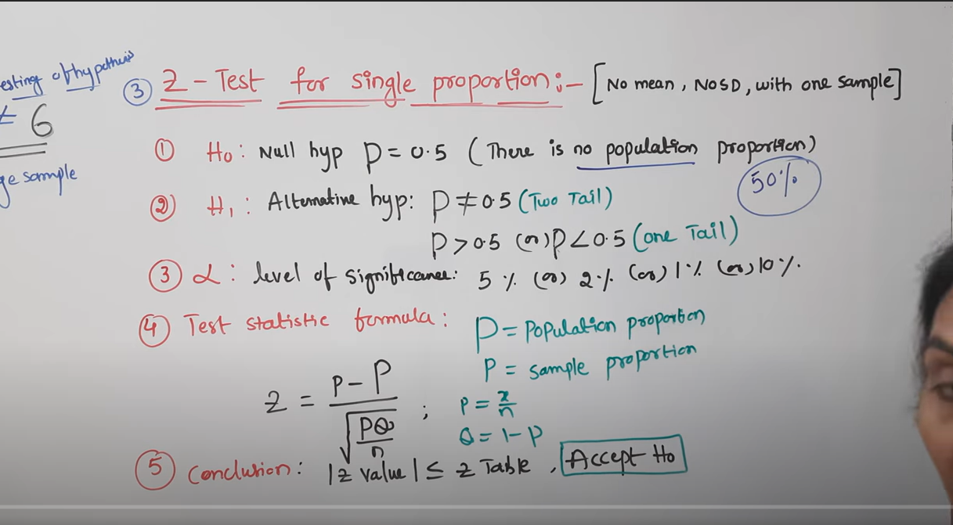

**Population proportion not given =0.5**

**p =X/N**

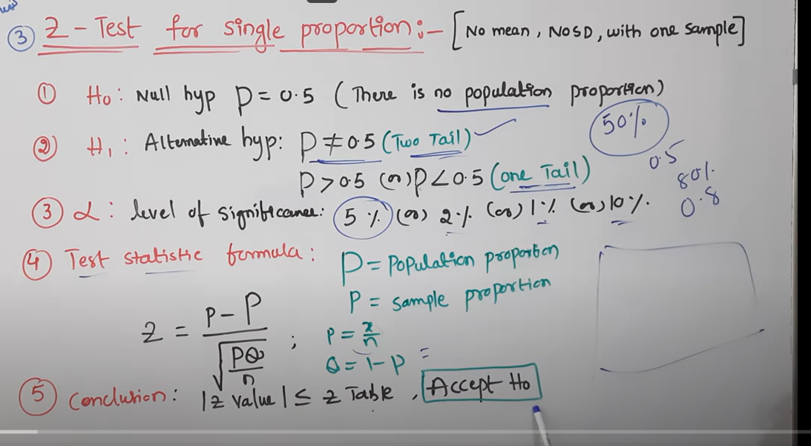

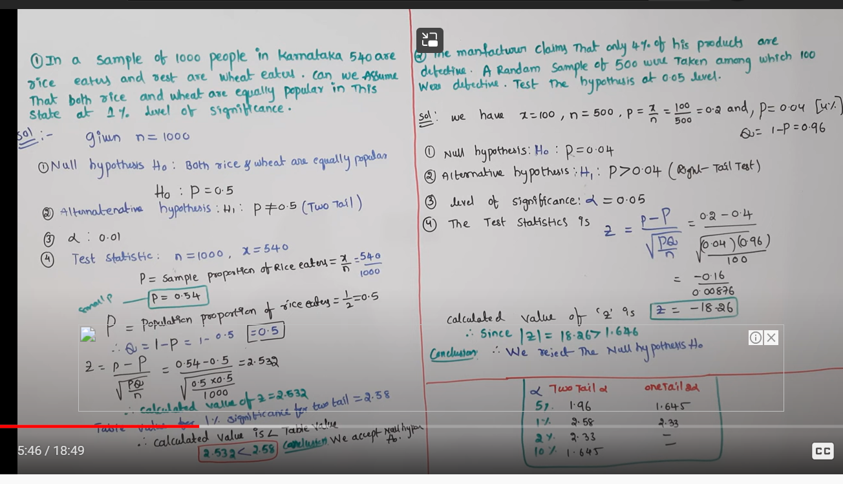

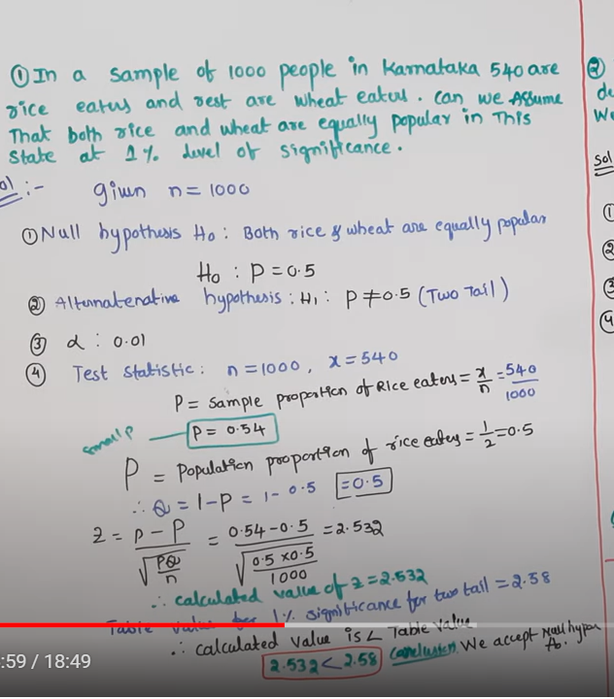

**ONE SAMPLE**

**NO MEAN’**

**NO SD**

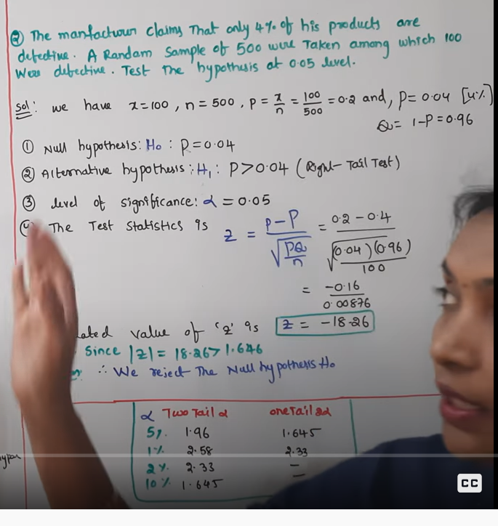

**4 PER ONLY DEFECTIVE**

**RANDOM SAMPLE OF 500 – 100 DEFECTIVE**

**NULL HYPOTHESIS : MANUFACTURE CHEPPINDI(ASSUMPTION)**

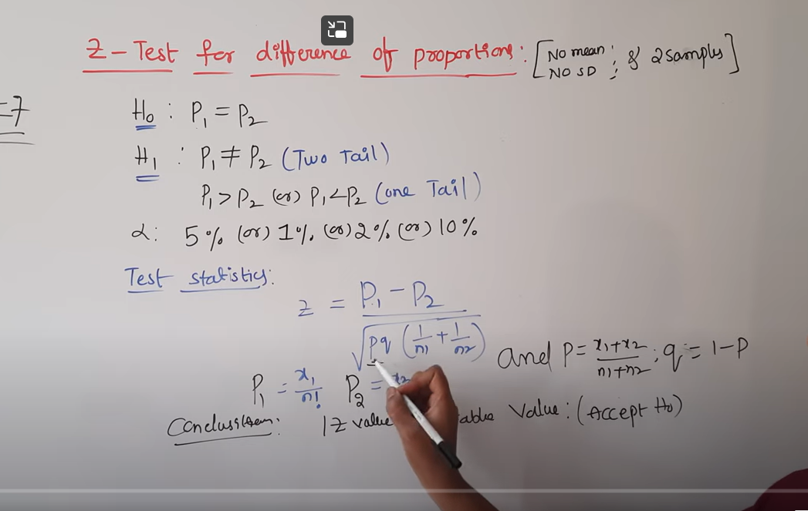

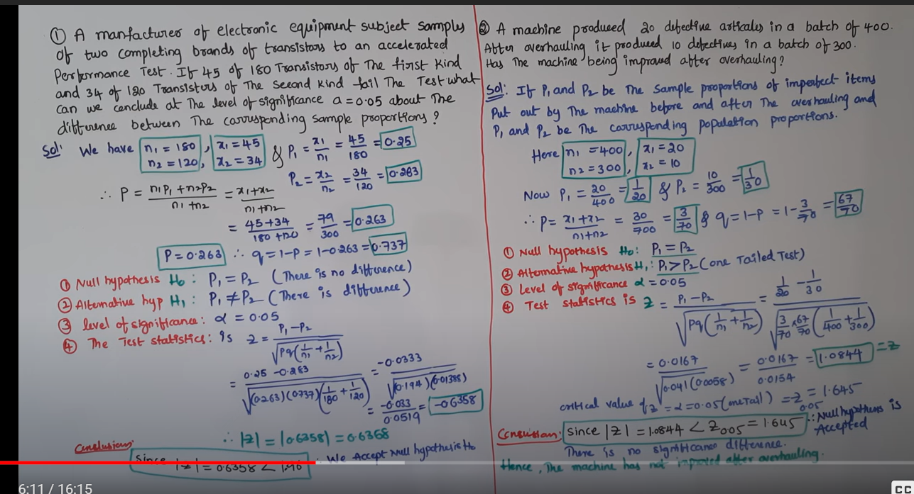

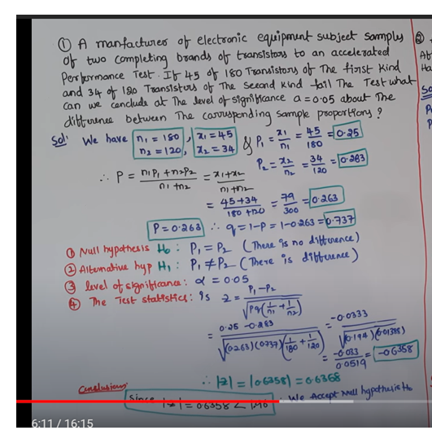

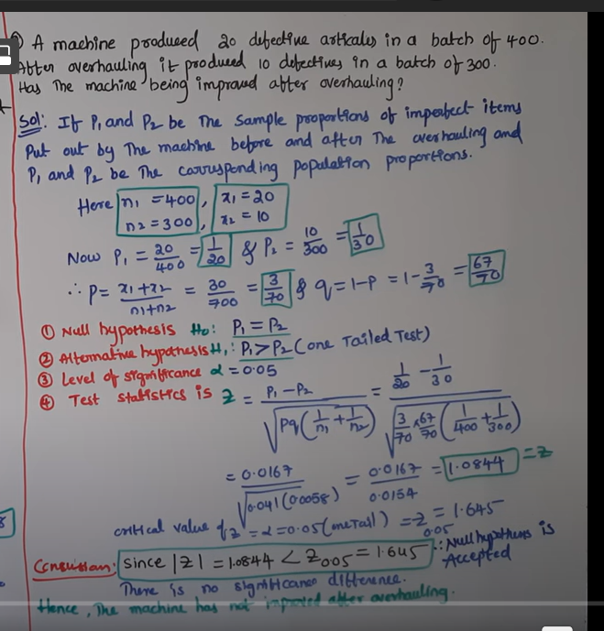

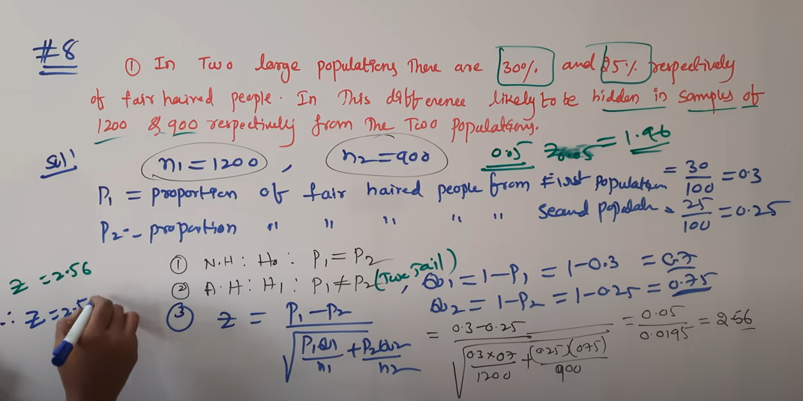

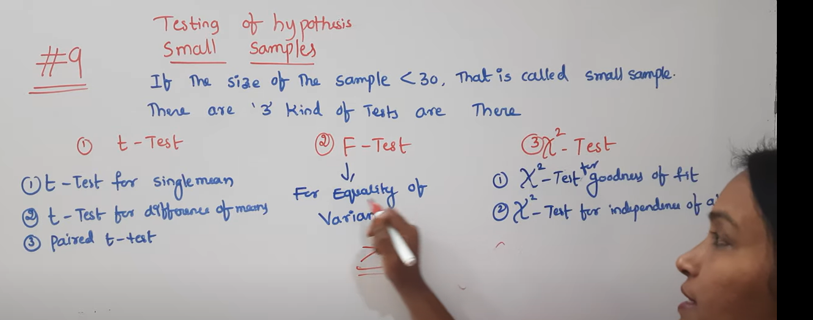

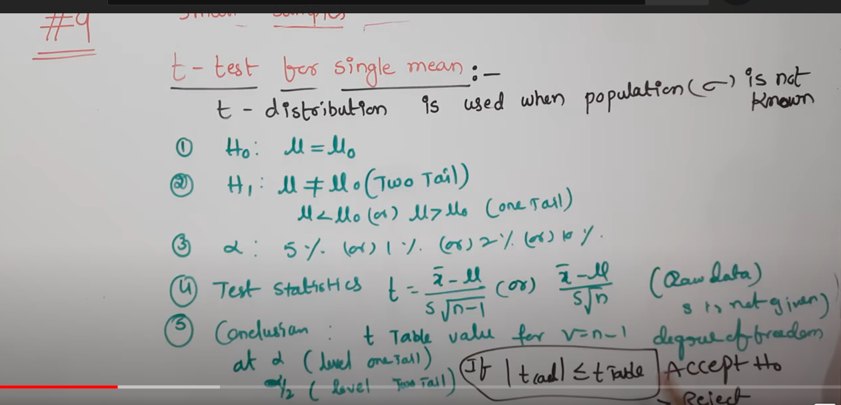

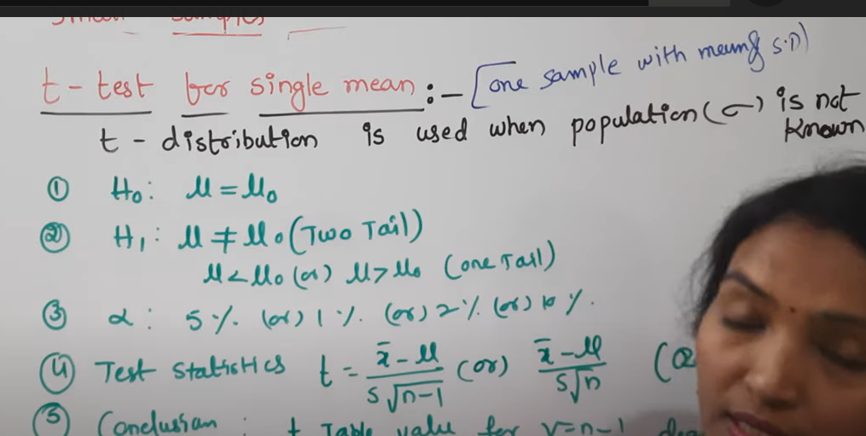

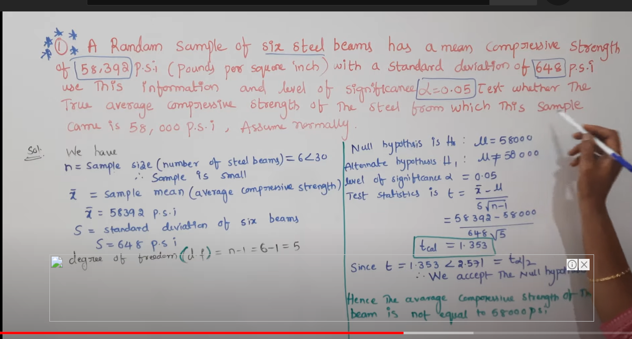

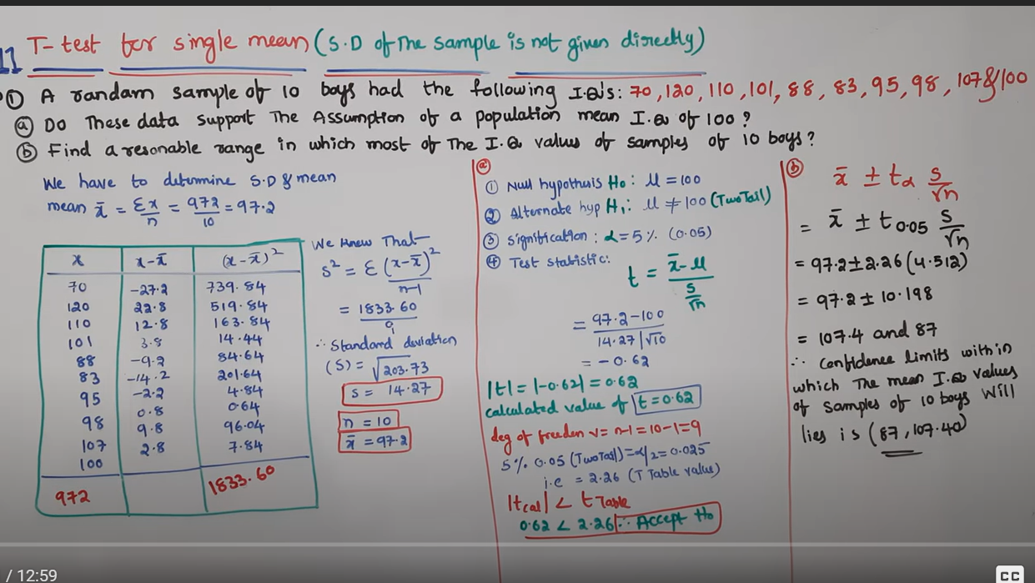

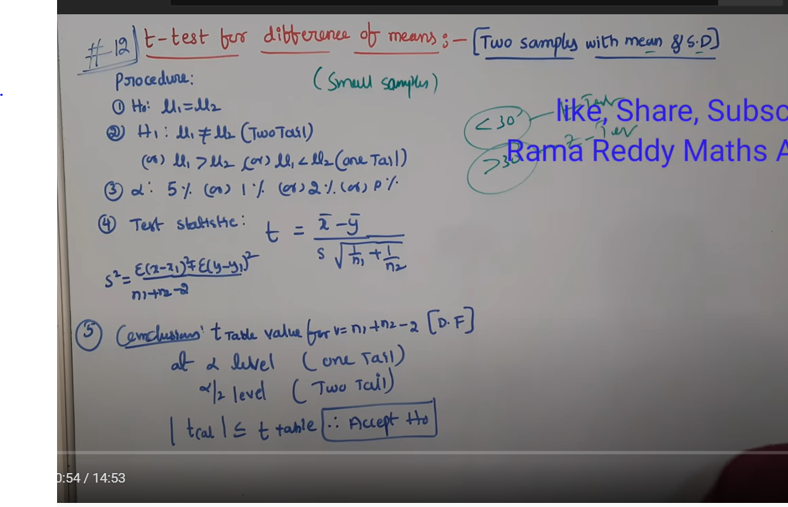

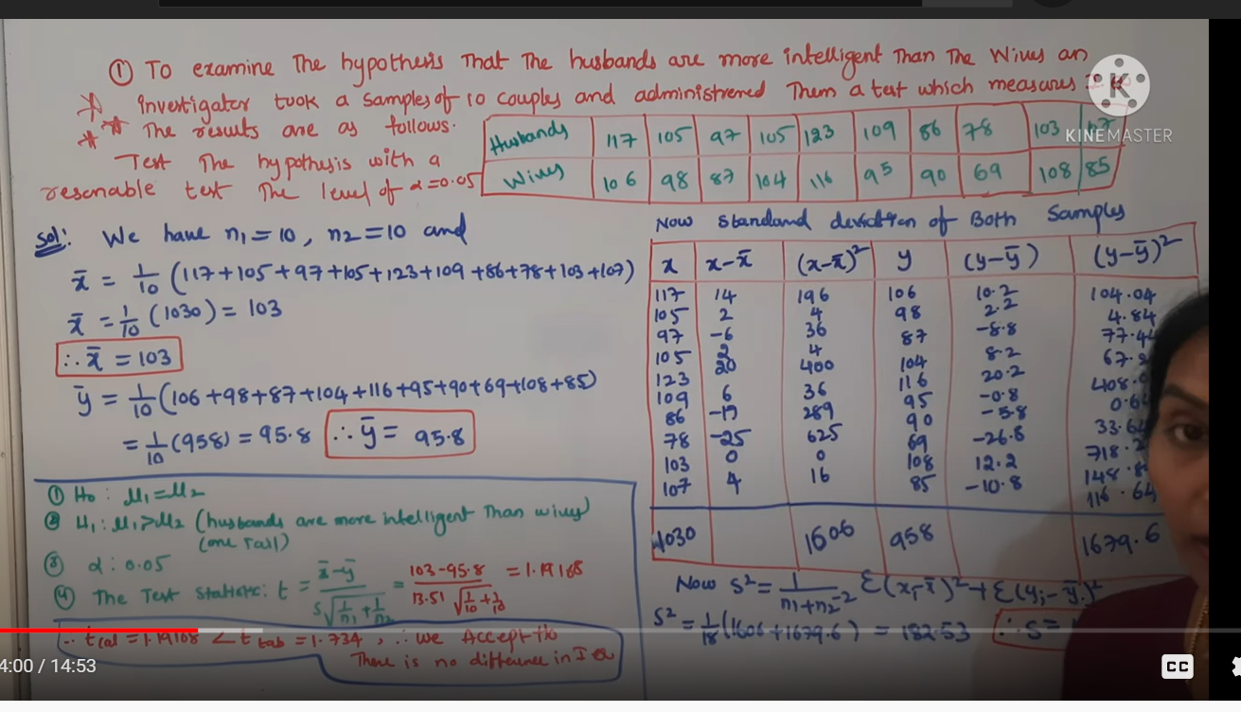

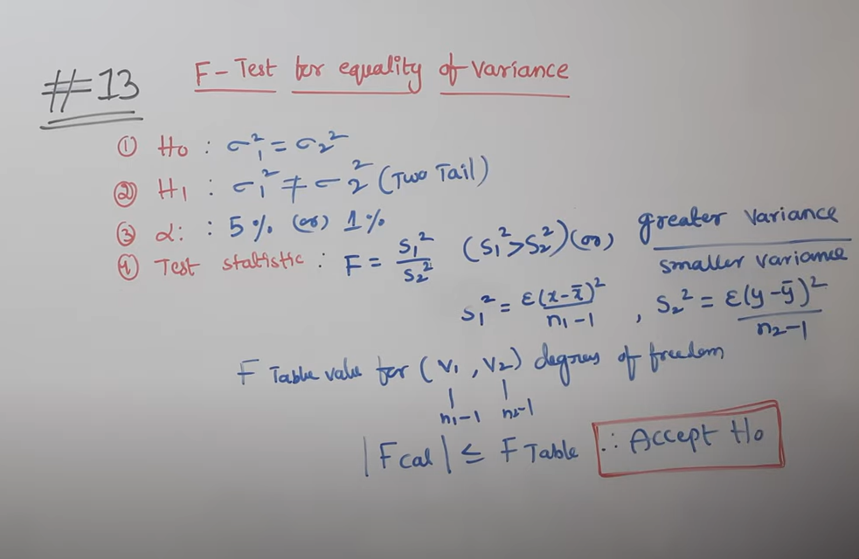

**Variance equality. Test whether two samples are taken from same population**

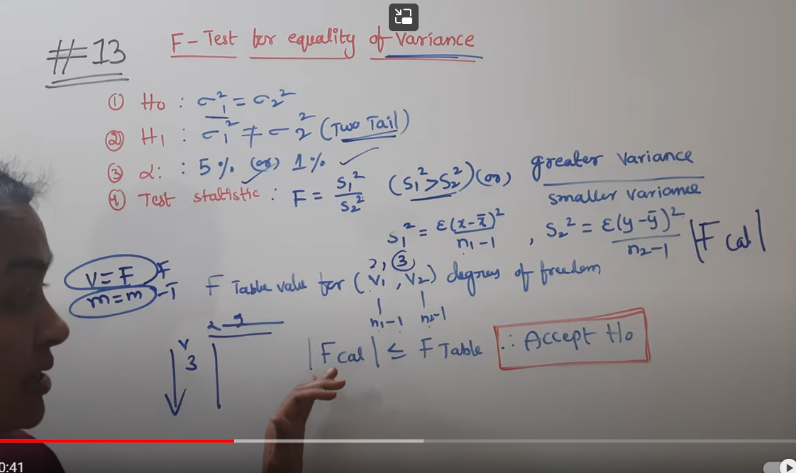

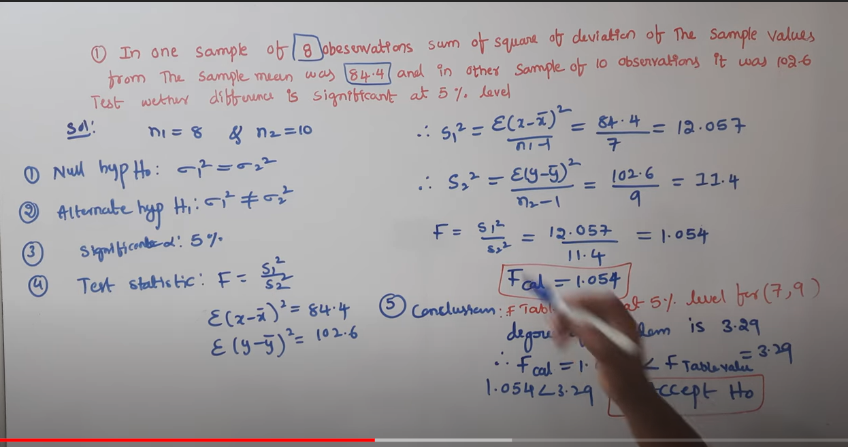

**Some squares of deviation from mean=**

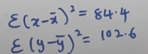

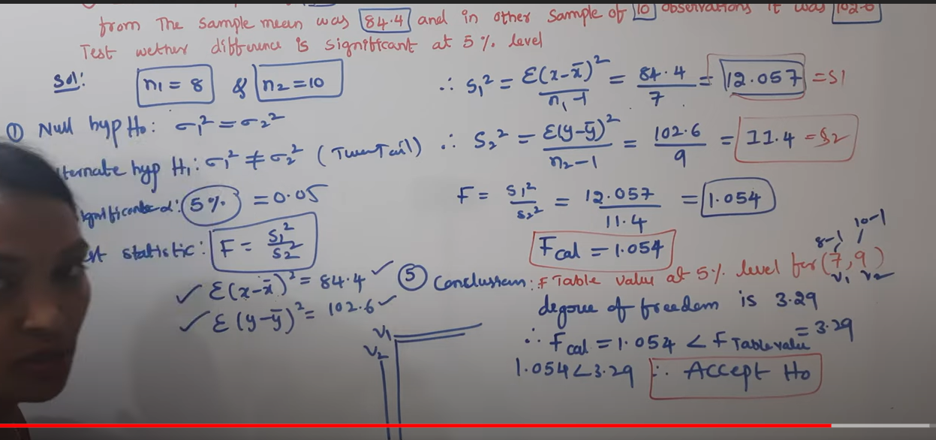

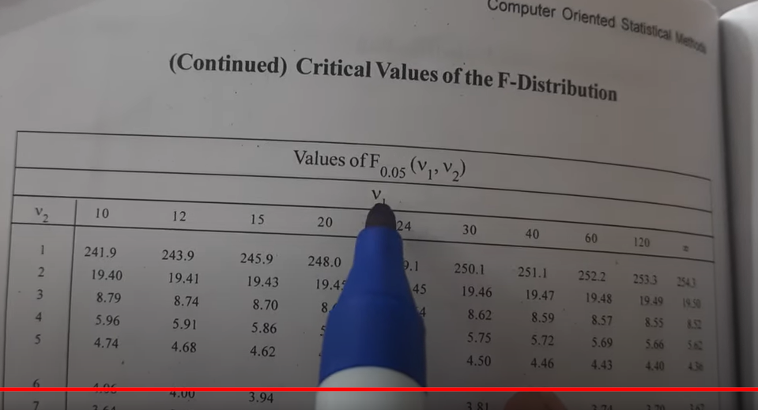

**Chi-Square distribution**

**Degrees of freedom:**

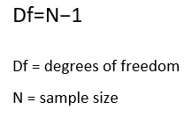

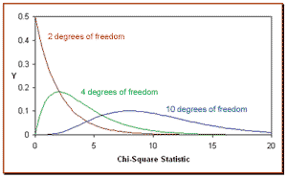

degrees of freedom increase Chi-Square distribution approximates to normal distribution.

**Chi-Square Test for Feature Selection**

A chi-square test is used in statistics to test the independence of two events. Given the data of two variables, we can get observed count O and expected count E. Chi-Square measures how expected count E and observed count O deviates each other.

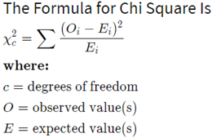

Let’s consider a scenario where we need to determine the relationship between the independent category feature (predictor) and dependent category feature(response). In feature selection, we aim to select the features which are highly dependent on the response.

When two features are independent, the observed count is close to the expected count, thus we will have smaller Chi-Square value. So high Chi-Square value indicates that the hypothesis of independence is incorrect. In simple words, higher the Chi-Square value the feature is more dependent on the response and it can be selected for model training.

Steps for Chi-Square Test with an example:

Consider a data-set where we have to determine why customers are leaving the bank, let’s perform a Chi-Square test for two variables. ***Gender***of a customer with values as Male/Female as the predictor and ***Exited***describes whether a customer is leaving the bank with values Yes/No as the response. In this test we will check*is there any relationship between Gender and Exited*.

Steps to perform the Chi-Square Test:

1. Define Hypothesis.
2. Build a Contingency table.
3. Find the expected values.
4. Calculate the Chi-Square statistic.
5. Accept or Reject the Null Hypothesis.

**1.Define Hypothesis**

Null Hypothesis (H0): Two variables are independent.

Alternate Hypothesis (H1): Two variables are not independent.

**2. Contingency table**

A table showing the distribution of one variable in rows and another in columns. It is used to study the relation between two variables.

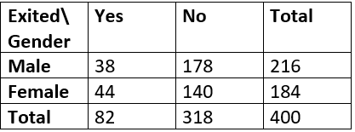

Contingency table for observed values

Degrees of freedom for contingency table is given as (r-1) * (c-1) where r,c are rows and columns. Here df = (2–1) * (2–1) = 1.

In the above table we have figured out all observed values and our next steps are to find expected values, get the Chi-Square value and check for relationship.

**3. Find the Expected Value**

Based on the null hypothesis that the two variables are independent. We can say if A, B are two independent events



Let’s calculate the expected value for the first cell that is those who are Males and are Exited from the bank.

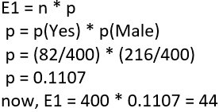

The calculation for the expected value

In similar, we calculate E2, E3, E4 and get the following results.

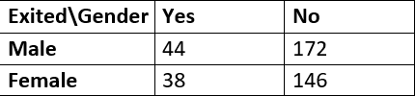

Expected values

**4. Calculate Chi-Square value**

Summarizing the observed values and calculated expected values into a table and determine the Chi-Square value.

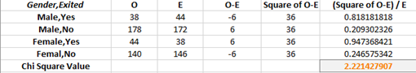

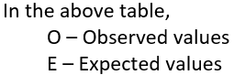

We can see Chi-Square is calculated as 2.22 by using the Chi-Square statistic formula.

**5. Accept or Reject the Null Hypothesis**

With 95% confidence that is alpha = 0.05, we will check the calculated Chi-Square value falls in the acceptance or rejection region.

Having degrees of freedom =1(calculated with contingency table) and alpha =0.05 the Chi-Square value is 3.84.

The Chi-Square values can be determined with the [Chi-Square table](https://web.ma.utexas.edu/users/davis/375/popecol/tables/chisq.html).

*The chi-square distribution is the right side since the difference in Observed and Expected is large.*

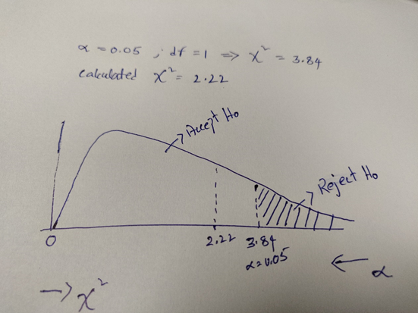

In the above fig, we can see Chi-Square ranges from 0 to inf and alpha ranges from 0 to 1 in the opposite direction. We will reject the Null hypothesis if Chi-Square value falls in the error region (alpha from 0 to 0.05 ).

So here we are accepting the null hypothesis since the Chi-Square value is less than the critical Chi-Square value.

*To conclude the two variables are independent, Gender variable cannot be selected for training the model.*

**Limitations**

Chi-Square is sensitive to small frequencies in cells of tables. Generally, when the expected value in a cell of a table is less than 5, chi-square can lead to errors in conclusions.

Note: Here we considered samples with size 400 and for the larger samples the results may vary.

**Chi-Square Test using Python**

Here is the below code, on how to perform the Chi-Square test using python.

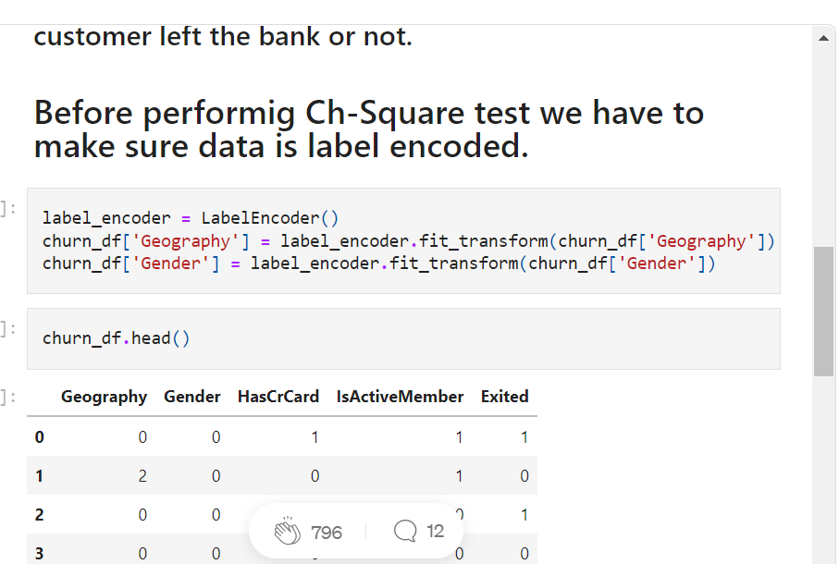

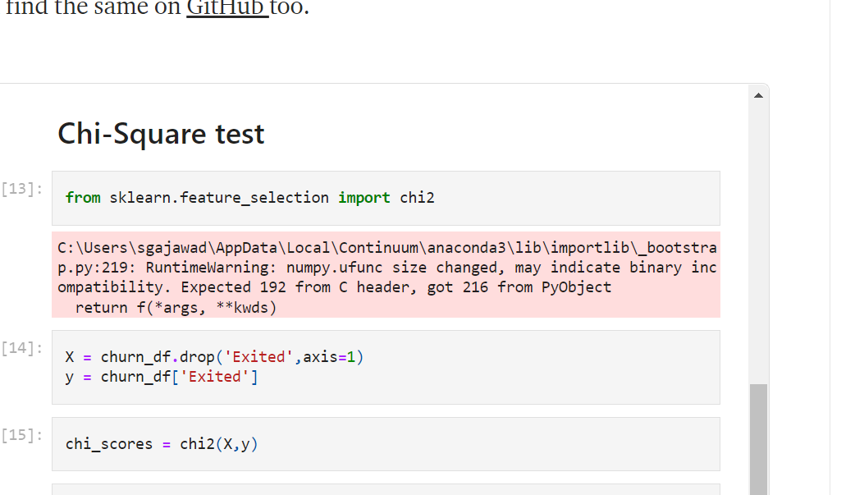

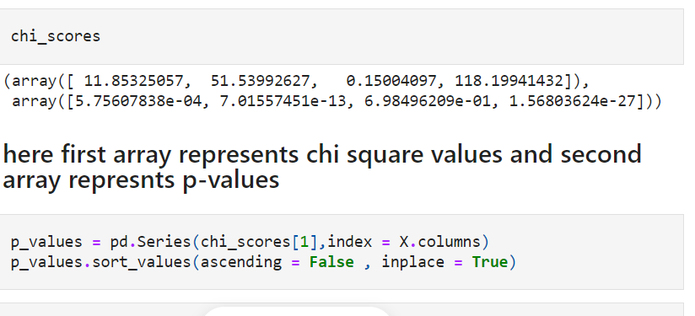

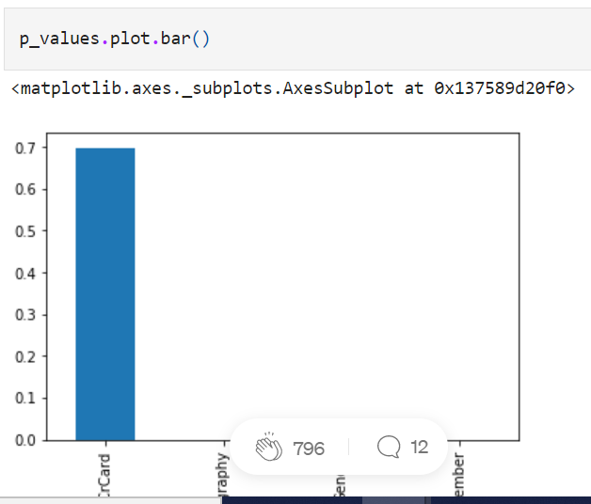

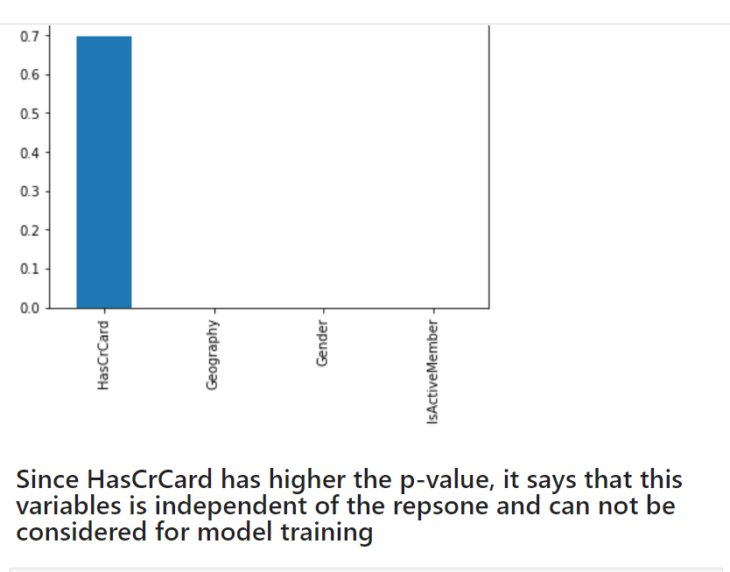

continuous response and categorical predictor ??? We will use ANOVA.

It helps to find out whether a difference between two categorical variables is due to chance or a relationship between them.

Gender and party

Color and gender

The chi-squared test helps to determine whether there is a notable difference between the normal frequencies and the observed frequencies in one or more classes or categories. It gives the probability of independent variables.

**Chi square test of goodness of test**

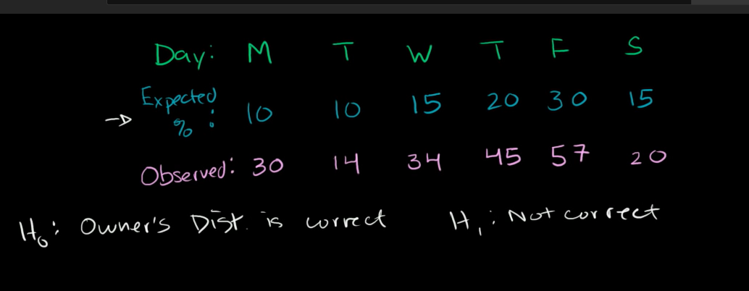

**To test whether owner distribution is correct or not**

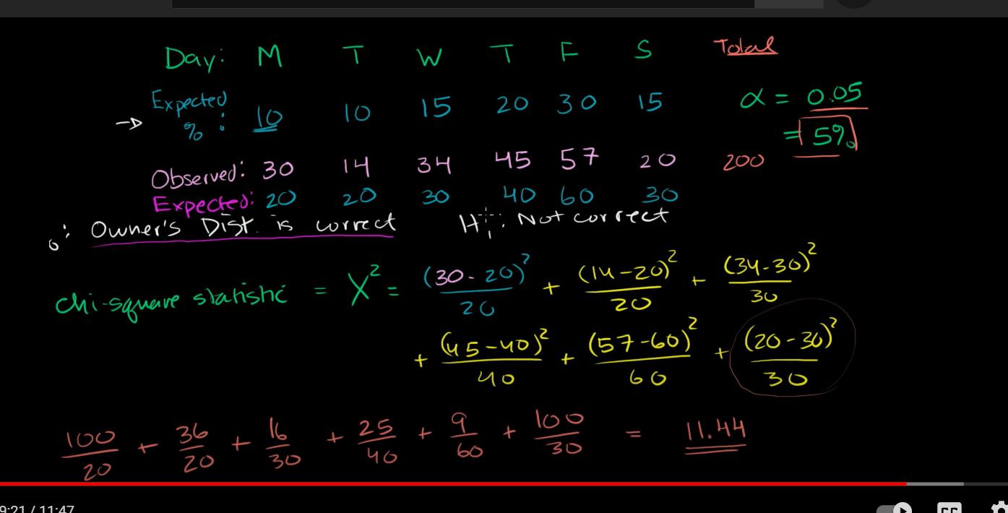

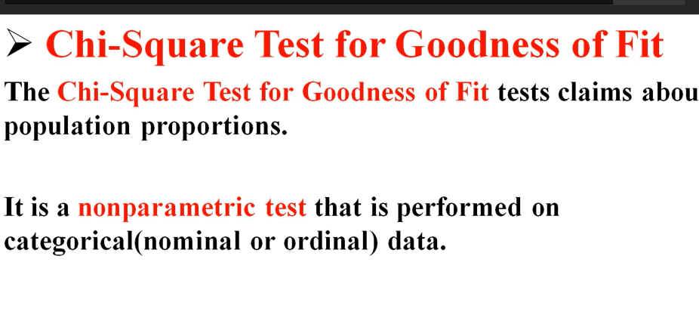

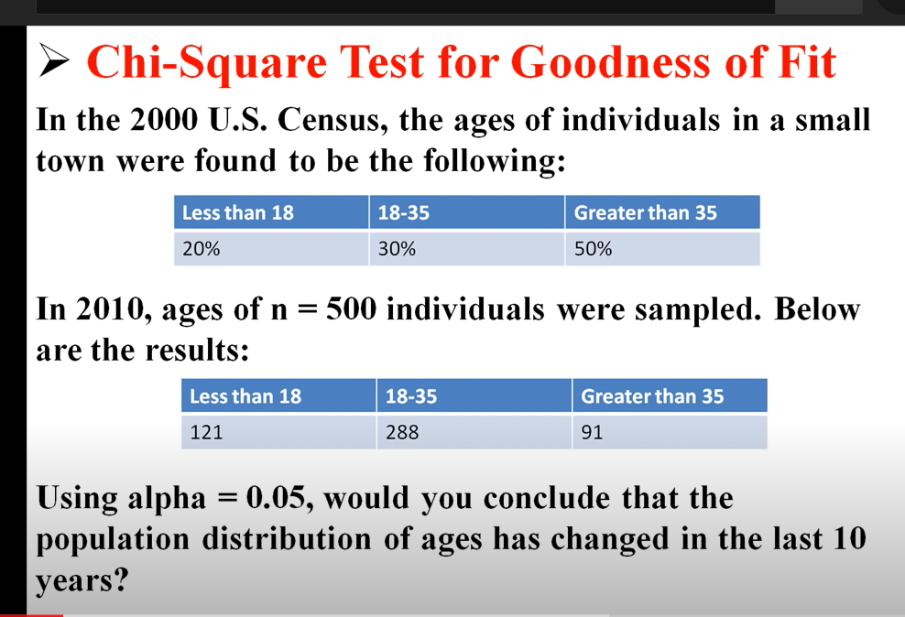

**Change in population distribution**

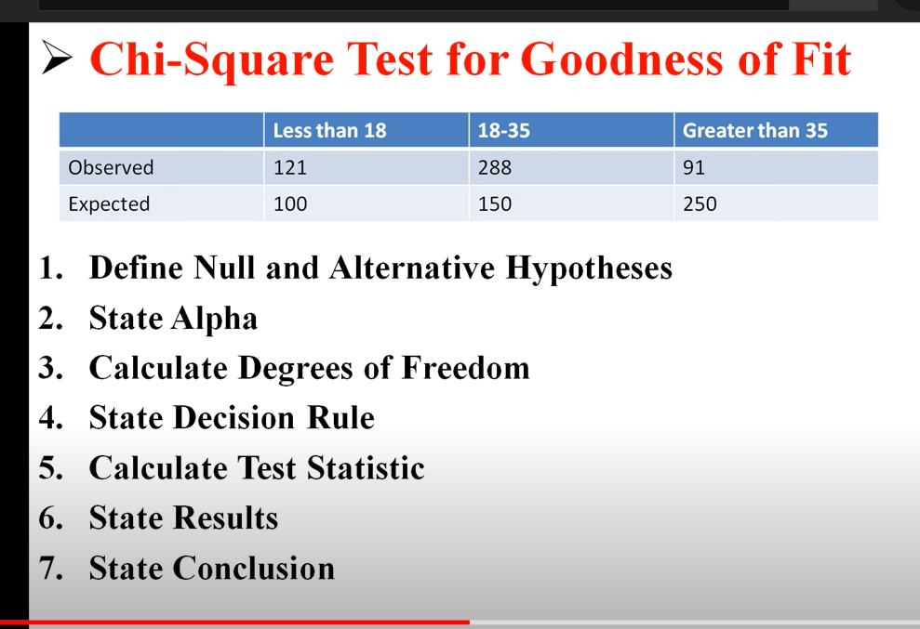

**One-Way ANOVA: Definition, Formula, and Example**

A **one-way ANOVA** (“analysis of variance”)

compares the **means of three or more independent groups** to determine if there is a statistically **significant difference between the corresponding population means**.

How each group in categorical independent value differ from population mean

This tutorial explains the following:

**One-Way ANOVA: Motivation**

**three different exam prep programs** lead to **different mean scores** on a college entrance exam.

Instead, we might select three [random samples](https://www.statology.org/sampling-methods/) of 100 students from the population and allow each sample to use one of the three test prep programs to prepare for the exam. Then, we could record the scores for each student once they take the exam.

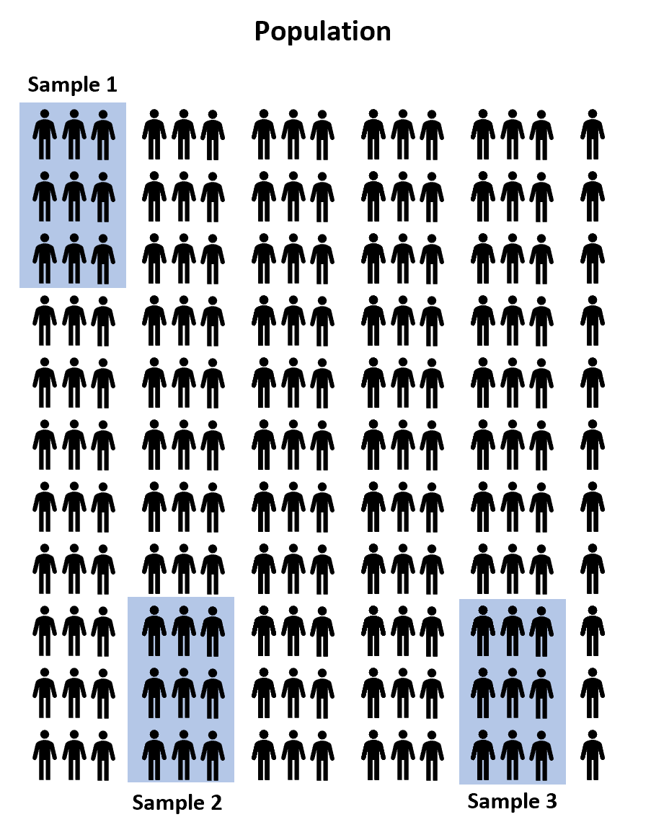

However, it’s virtually guaranteed that the mean exam score between the three samples will **be at least a little different**.

**The question is whether or not this difference is statistically significant**. Fortunately, a one-way ANOVA allows us to answer this question.

**One-Way ANOVA: Assumptions**

For the results of a one-way ANOVA to be valid, the following assumptions should be met:

**1. Normality**– Each sample was drawn from a **normally distributed population.**

**2. Equal Variances**– **The variances of the populations** that the samples come from are equal. You can use [Bartlett’s Test](https://www.statology.org/bartletts-test/) to verify this assumption.

**3. Independence**– The o**bservations in each group are independent** of each other and the observations within groups were obtained by a random sample.

**One-Way ANOVA: The Process**

A one-way ANOVA uses the following null and alternative hypotheses:

* **H0(null hypothesis):** μ1 = μ2 = μ3= … = μk(all the population means are equal)
* **H1(alternative hypothesis):** at least one population mean is differentfrom the rest

where:

* **SSR:** regression sum of squares
* **SSE:** error sum of squares
* **SST:** total sum of squares (SST = SSR + SSE)
* **dfr:** regression degrees of freedom (dfr= k-1)
* **dfe:** error degrees of freedom (dfe= n-k)
* **dft:** total degrees of freedom (dft= n-1)
  + **k:**total number of groups
  + **n:**total observations
* **MSR:**regression mean square (MSR = SSR/dfr)
* **MSE:**error mean square (MSE = SSE/dfe)
* **F:**The F test statistic (F = MSR/MSE)
* **p:**The p-value that corresponds to Fdfr, dfe

If the p-value is less than your chosen significance level (e.g. 0.05), then you can reject the null hypothesis and conclude that at least one of the population means is different from the others.

**Note:**If you reject the null hypothesis, this indicates that at least one of the population means is different from the others, but the **ANOVA table doesn’t specify *which*population means are different.** To determine this, you need to perform [**post hoc tests**](https://www.statology.org/anova-post-hoc-tests/)**, also known as “multiple comparisons” tests.**

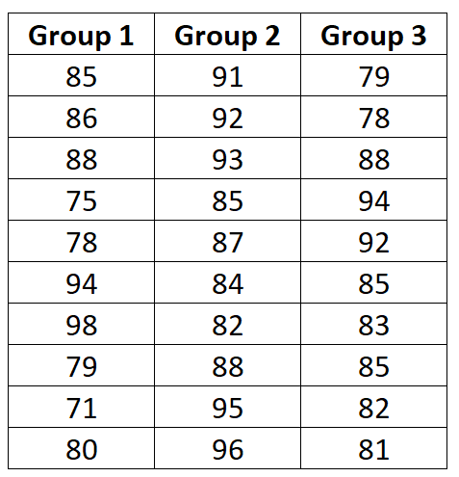

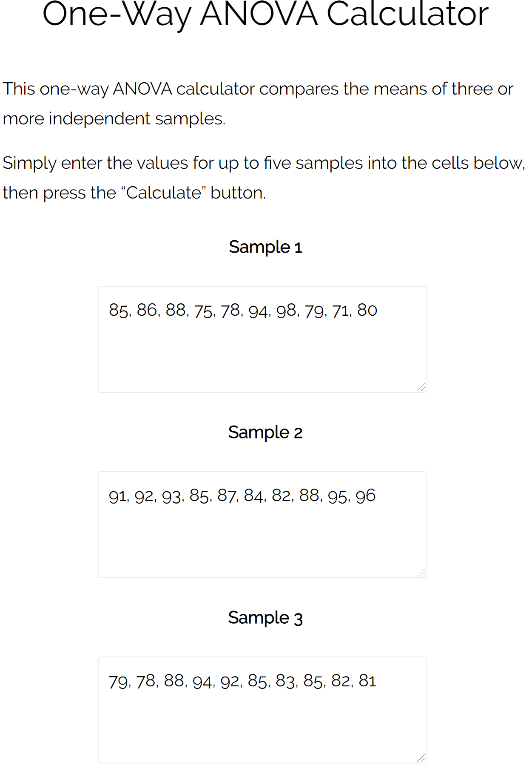

From the output table we see that the F test statistic is **2.358**and the corresponding p-value is **0.11385**.

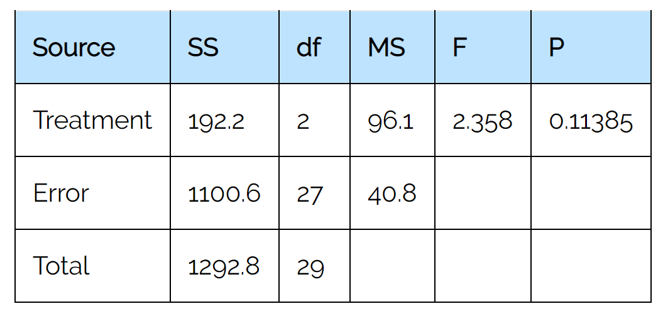

Since this p-value is not less than 0.05, we fail to reject the null hypothesis.

This means we don’t have sufficient evidence to say that there is a statistically significant difference between the mean exam scores of the three groups.

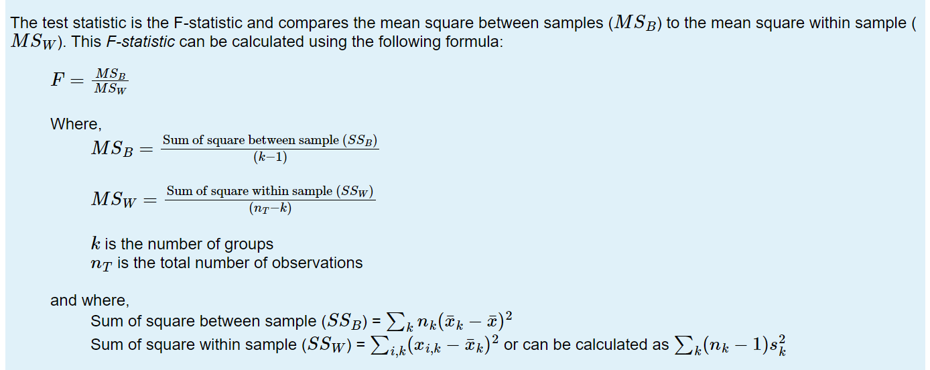

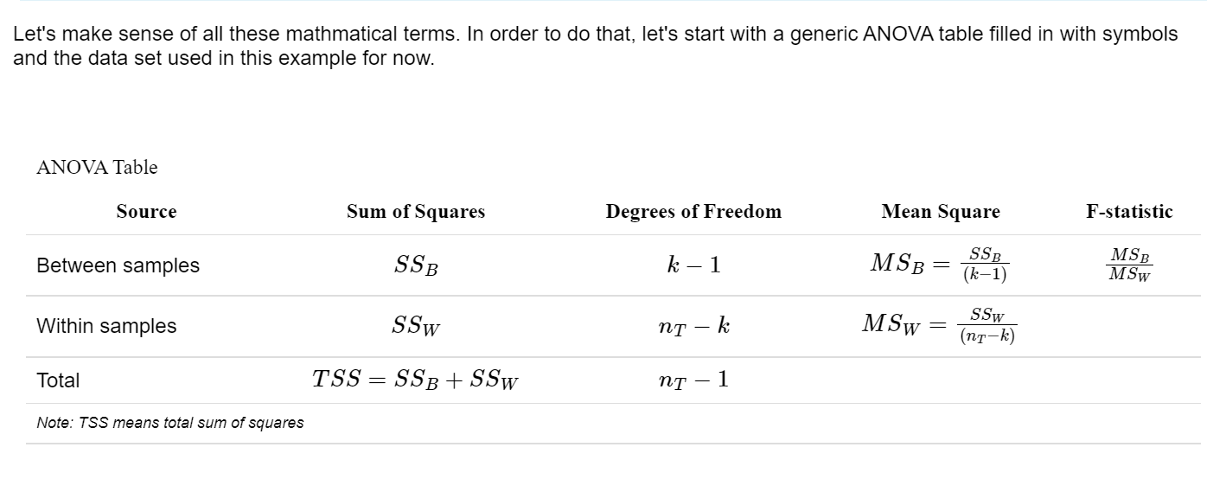

**Two-way ANOVA | When and How to Use it, With Examples**

**Published on March 20, 2020 by**[**Rebecca Bevans**](https://www.scribbr.com/author/beccabevans/)**. Revised on May 6, 2022.**

ANOVA (Analysis of Variance) is a [statistical test](https://www.scribbr.com/statistics/statistical-tests/) used to analyze the difference between the means of more than two groups.

A two-way ANOVA is used to estimate how the[**mean**](https://www.scribbr.com/statistics/mean/)**of a**[**quantitative variable**](https://www.scribbr.com/methodology/types-of-variables/)**changes according to the levels of two categorical variables.**

**two independent variables, in combination, affect a dependent variable.**

type of fertilizer

planting density

crop yield

fertilizer type (1, 2, or 3) and planting density (1=low density, 2=high density

You can use a two-way ANOVA to find out if fertilizer type and planting density have an effect on average crop yield.

**When to use a two-way ANOVA**

You can use a two-way ANOVA when you have collected data on a **quantitative**[**dependent variable**](https://www.scribbr.com/methodology/independent-and-dependent-variables/) at multiple levels of two categorical independent variables.

A **categorical variable** represents types or categories of things. A level is an individual category within the categorical variable.

Fertilizer types 1, 2, and 3 are levels within the categorical variable **fertilizer type**. Planting densities 1 and 2 are levels within the categorical variable **planting density**.

variables.

Both of your independent variables should be categorical. **If one of your independent variables is categorical and one is quantitative, use an ANCOVA instead.**

**How does the ANOVA test work?**

ANOVA tests for significance using the F-test for [statistical significance](https://www.scribbr.com/statistics/statistical-significance/).

The F-test is a groupwise comparison test, which means it compares **the**[**variance**](https://www.scribbr.com/statistics/variance/)**in each group mean** to the **overall variance in the dependent variable.**

If the **variance within groups is smaller** than the **variance between groups**,

the F-test will find a **higher F-value**, and therefore a **higher likelihood that the difference observed is real** and not due to chance.

A two-way ANOVA with interaction tests three [null hypotheses](https://www.scribbr.com/statistics/null-and-alternative-hypotheses/) at the same time:

* There is **no difference in group means** at any level of the **first independent variable.**
* There is **no difference in group means** at any level of the **second independent variable.**
* **The effect of one independent variable** does not depend on the **effect of the other independent variable** (a.k.a. no interaction effect).

A two-way **ANOVA without interaction** (a.k.a. an additive two-way ANOVA) only tests the **first two of these hypotheses**.

Two-way ANOVA hypothesesIn our crop yield experiment, we can test three hypotheses using two-way ANOVA:

| **Null hypothesis (H0)** | **Alternate hypothesis (Ha)** |
| --- | --- |
| There is no difference in average yield for any fertilizer type. | There is a difference in average yield by fertilizer type. |
| There is no difference in average yield at either planting density. | There is a difference in average yield by planting density. |
| The effect of one independent variable on average yield does not depend on the effect of the other independent variable (a.k.a. no interaction effect). | There is an interaction effect between planting density and fertilizer type on average yield. |

**Assumptions of the two-way ANOVA**

To use a two-way ANOVA your data should meet certain assumptions.Two-way ANOVA makes all of the normal assumptions of a parametric test of difference:

1. **Homogeneity of variance** (a.k.a. homoscedasticity)

The variation around the mean for each group being compared should be similar among all groups. If your data don’t meet this assumption, you may be able to use a [non-parametric alternative](https://www.scribbr.com/statistics/statistical-tests/#nonparametric), like the **Kruskal-Wallis test.**

1. Independence of observations

In the crop-yield example, the response variable is normally distributed, and we can [check for homoscedasticity](https://www.scribbr.com/statistics/anova-in-r/#step-5-check-for-homoscedasticity) after running the model. The experimental treatments were set up within blocks in the field, with four blocks each containing every possible combination of fertilizer type and planting density, so we should include this as a blocking variable in the model.

**How to perform a two-way ANOVA**

The dataset from our imaginary crop yield experiment includes observations of:

* Final crop yield (bushels per acre)
* Type of fertilizer used (fertilizer type 1, 2, or 3)
* Planting density (1=low density, 2=high density)
* Block in the field (1, 2, 3, 4).

The two-way ANOVA will test whether the independent variables (fertilizer type and planting density) have an effect on the dependent variable (average crop yield). But there are some other possible sources of variation in the data that we want to take into account.

We applied our experimental treatment in blocks, so we want to know if planting block makes a difference to average crop yield. We also want to check if there is an interaction effect between two independent variables – for example, it’s possible that planting density affects the plants’ ability to take up fertilizer.

Because we have a few different possible relationships between our variables, we will compare three models:

1. A two-way ANOVA without any interaction or blocking variable (a.k.a an additive two-way ANOVA).
2. A two-way ANOVA with interaction but with no blocking variable.
3. A two-way ANOVA with interaction and with the blocking variable.

Model 1 assumes there is no interaction between the two independent variables. Model 2 assumes that there is an interaction between the two independent variables. Model 3 assumes there is an interaction between the variables, and that the blocking variable is an important source of variation in the data.

By running all three versions of the two-way ANOVA with our data and then comparing the models, we can efficiently test which variables, and in which combinations, are important for describing the data, and see whether the planting block matters for average crop yield.

This is not the only way to do your analysis, but it is a good method for efficiently comparing models based on what you think are reasonable combinations of variables.

**Running a two-way ANOVA in R**

We will run our analysis in R. To try it yourself, download the sample dataset.

[**Sample dataset for a two-way ANOVA**](https://cdn.scribbr.com/wp-content/uploads/2020/03/crop.data_.anova_.zip)

After loading the data into the R environment, we will create each of the three models using the aov() command, and then compare them using the aictab() command. For a full walkthrough, see our guide to [ANOVA in R](https://www.scribbr.com/statistics/anova-in-r/).

This first model does not predict any interaction between the independent variables, so we put them together with a ‘+’.

Two-way ANOVA R codetwo.way <- aov(yield ~ fertilizer + density, data = crop.data)

In the second model, to test whether the interaction of fertilizer type and planting density influences the final yield, use a ‘ * ‘ to specify that you also want to know the interaction effect.

Two-way ANOVA with interaction R codeinteraction <- aov(yield ~ fertilizer * density, data = crop.data)

Because our crop treatments were randomized within blocks, we add this variable as a blocking factor in the third model. We can then compare our two-way ANOVAs with and without the blocking variable to see whether the planting location matters.

Two-way ANOVA with blocking R codeblocking <- aov(yield ~ fertilizer * density + block, data = crop.data)

**Model comparison**

Now we can find out which model is the best fit for our data using AIC ([Akaike information criterion](https://www.scribbr.com/statistics/akaike-information-criterion/)) model selection.

AIC calculates the best-fit model by finding the model that explains the largest amount of variation in the response variable while using the fewest parameters. We can perform a model comparison in R using the aictab() function.

AIC R code

library(AICcmodavg)

model.set <- list(two.way, interaction, blocking)

model.names <- c("two.way", "interaction", "blocking")

aictab(model.set, modnames = model.names)

The output looks like this:

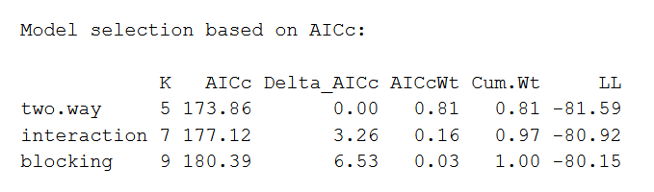

The AIC model with the best fit will be listed first, with the second-best listed next, and so on. This comparison reveals that the two-way ANOVA without any interaction or blocking effects is the best fit for the data.

**Interpreting the results of a two-way ANOVA**

You can view the summary of the two-way model in R using the summary() command. We will take a look at the results of the first model, which we found was the best fit for our data.

Two-way ANOVA summary R codesummary(two.way)

The output looks like this:

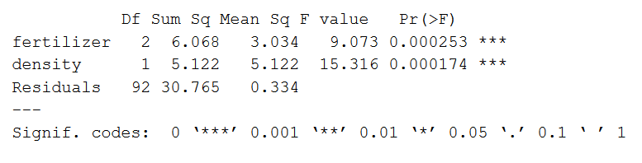

The model summary first lists the independent variables being tested (‘fertilizer’ and ‘density’). Next is the residual variance (‘Residuals’), which is the variation in the dependent variable that isn’t explained by the independent variables.

The following columns provide all of the information needed to interpret the model:

* **Df** shows the degrees of freedom for each variable (number of levels in the variable minus 1).
* **Sum sq** is the sum of squares (a.k.a. the variation between the group means created by the levels of the independent variable and the overall mean).
* **Mean sq** shows the mean sum of squares (the sum of squares divided by the degrees of freedom).
* **F value** is the [test statistic](https://www.scribbr.com/statistics/test-statistic/) from the F-test (the mean square of the variable divided by the mean square of each parameter).
* **Pr(>F)** is the [p-value](https://www.scribbr.com/statistics/p-value/) of the F statistic, and shows how likely it is that the F-value calculated from the F-test would have occurred if the null hypothesis of no difference was true.

From this output we can see that both fertilizer type and planting density explain a significant amount of variation in average crop yield (p-values < 0.001).

**Post-hoc testing**

ANOVA will tell you which parameters are significant, but not which levels are actually different from one another. To test this we can use a post-hoc test. The Tukey’s Honestly-Significant-Difference (TukeyHSD) test lets us see which groups are different from one another.

Tukey R codeTukeyHSD(two.way)

The output looks like this:

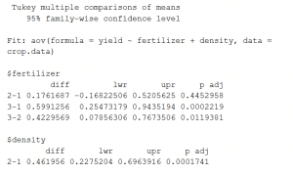

This output shows the pairwise differences between the three types of fertilizer ($fertilizer) and between the two levels of planting density ($density), with the average difference (‘diff’), the lower and upper bounds of the 95% [confidence interval](https://www.scribbr.com/statistics/confidence-interval/) (‘lwr’ and ‘upr’) and the p-value of the difference (‘p-adj’).

From the post-hoc test results, we see that there are significant differences (p < 0.05) between:

* fertilizer groups 3 and 1,
* fertilizer types 3 and 2,
* the two levels of planting density,

but no difference between fertilizer groups 2 and 1.

**How to present the results of a a two-way ANOVA**

Once you have your model output, you can report the results in the results section of your paper.

When reporting the results you should include the f-statistic, degrees of freedom, and p-value from your model output.

Example resultsWe found a statistically-significant difference in average corn yield by both fertilizer type (f(2)=9.018, p < 0.001) and by planting density (f(1)=15.316, p<0.001), though the interaction between these terms was not significant.

A Tukey post-hoc test revealed significant pairwise differences between fertilizer mix 3 and fertilizer mix 1 (+ 0.59 bushels/acre under mix 3), between fertilizer mix 3 and fertilizer mix 2 (+ 0.42 bushels/acre under mix 2), and between planting density 2 and planting density 1 ( + 0.46 bushels/acre under density 2).

You can discuss what these findings mean in the discussion section of your paper.

Example discussionThe increased production under fertilizer mix 3 and at higher planting densities suggests that under field conditions similar to ours, this combination would be most advantageous for crop yield. The lack of interaction between fertilizer type and planting densities suggests that planting density does not affect the ability of the plants to take up fertilizer, though at densities higher than ours this may become the case.

You may also want to [make a graph](https://www.scribbr.com/statistics/anova-in-r/#anova-graph) of your results to illustrate your findings.

Your graph should include the groupwise comparisons tested in the ANOVA, with the raw data points, summary statistics (represented here as means and [standard error](https://www.scribbr.com/statistics/standard-error/) bars), and letters or significance values above the groups to show which groups are significantly different from the others.

**Hypothesis**

Assumption about parameter

Uses data of sample

Null hypo

Alternative hypo

Some cases easy to formulate alternative hypo first

Most of the time research wants to find alternative hypo

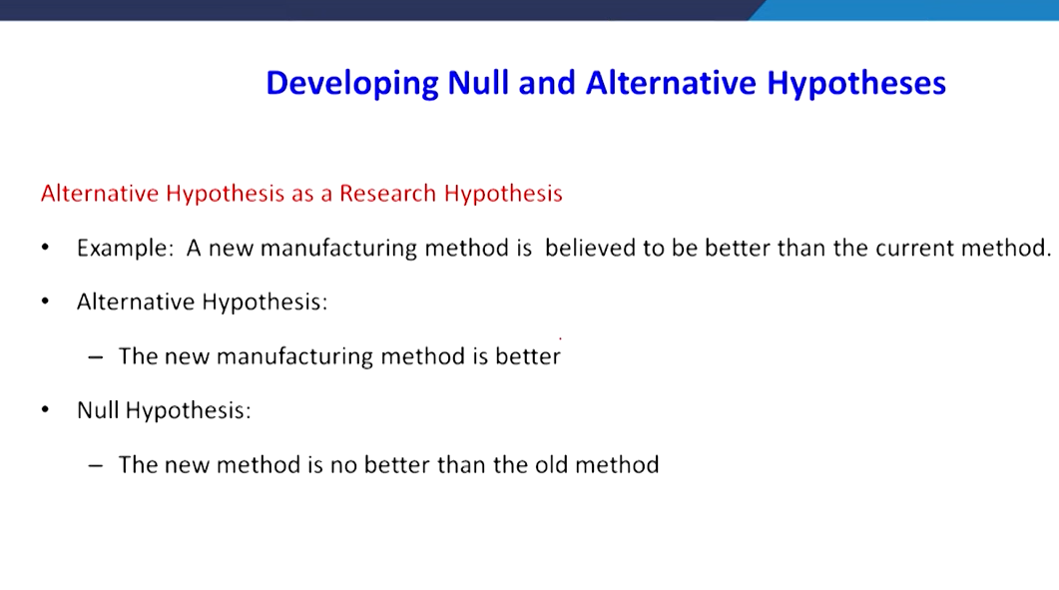

That’s why researcher wants to make alternative first

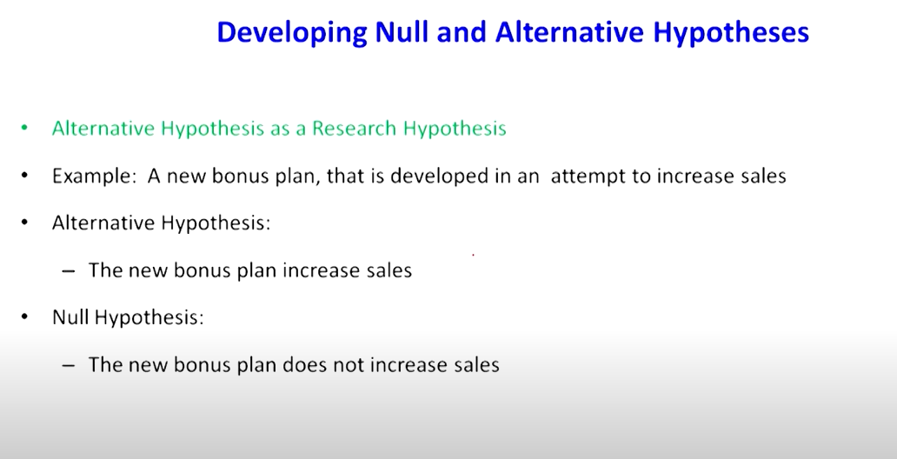

Null hypo:

Assumption to be challenged

First we must assume h0 is true

We must find evidences to challenge h0

Equality or statusqo or nothing has happened---- h0

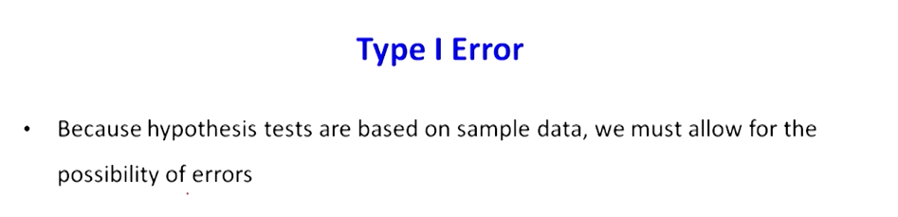

Type1 error: incorrect rejection

Alpha or producer risk

Producer risk- producer produced sharp with 50m diameter

Consumer reduced thinking its not 50m, customer rejected good quality

Though goods are good they rejected

Type2:

or false acceptance

Its difficult to control type 2 error

Consumer risk

Producer prepared 49mm but customer thought its 50 and purchased

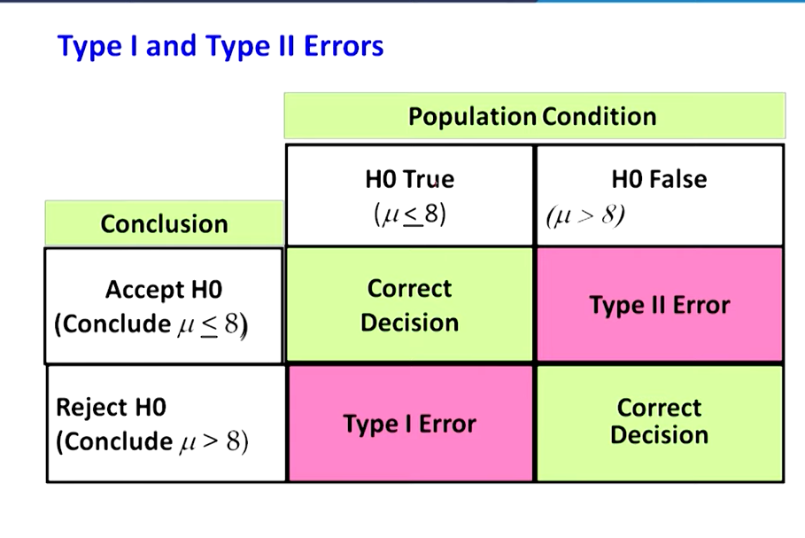

P value says whether its supporting null hypo or not

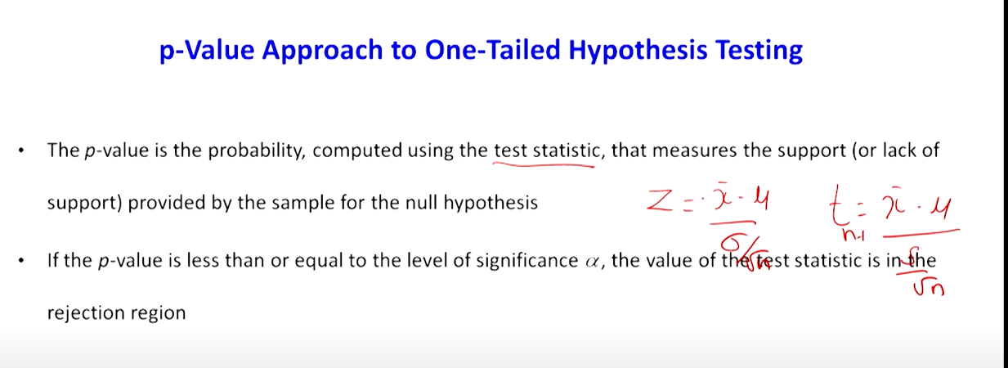

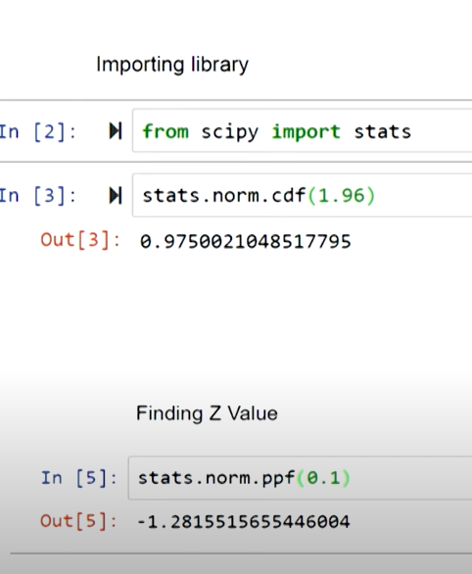

1.96 is z value

We found area under curve

Hypothesis testing: p value approach and critical value approach

P value approach: comparing p value and probability

Critical value approach : calculated z value and critical value

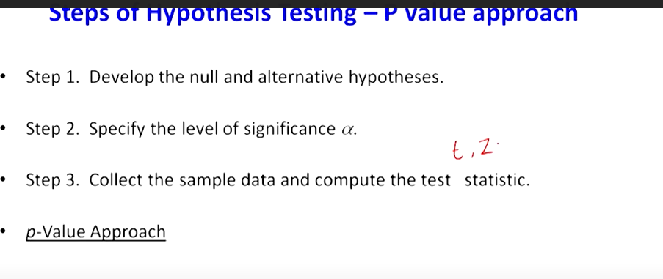



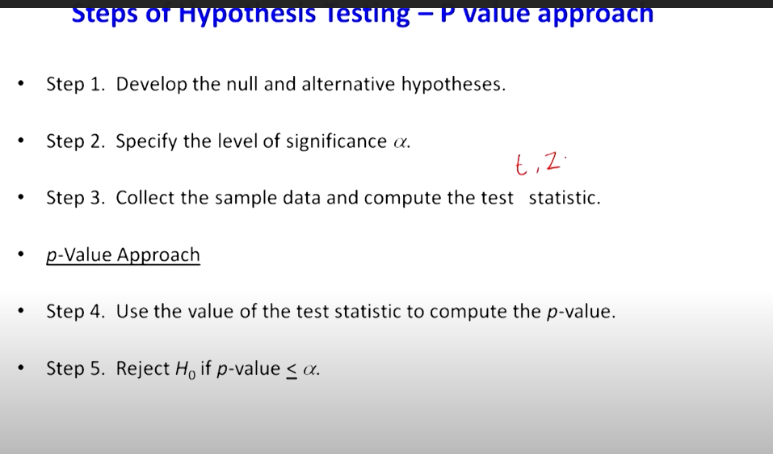

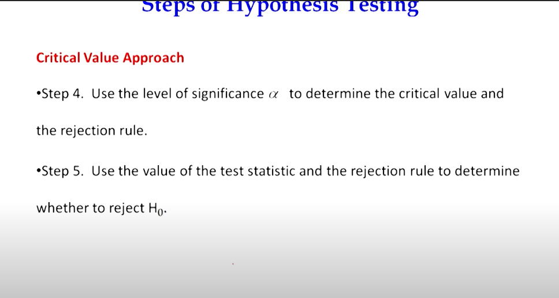

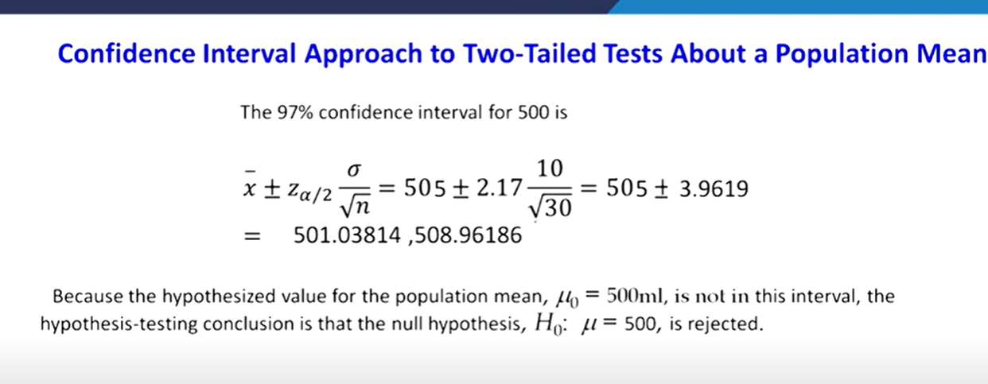

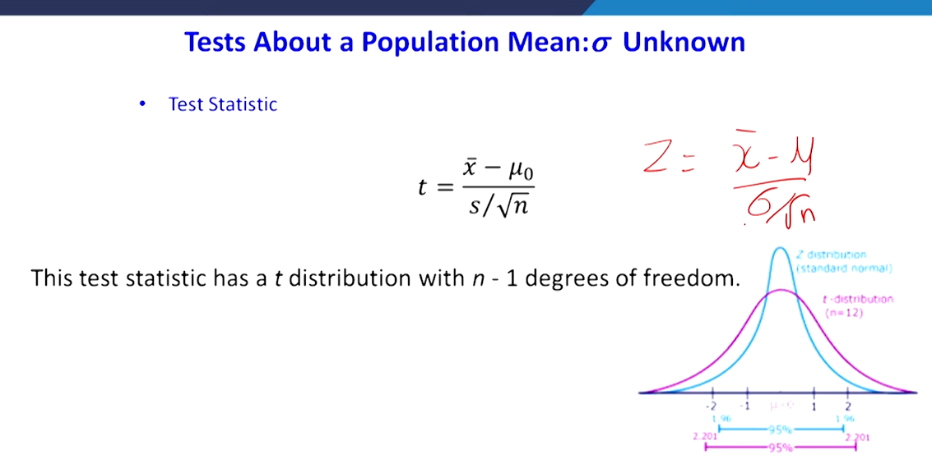

**When n size is increasing the behavior of distribution becoming normal distribution so behavior of z test and t test will be similar**

**Shape of t distribution effected by degree of freedom**

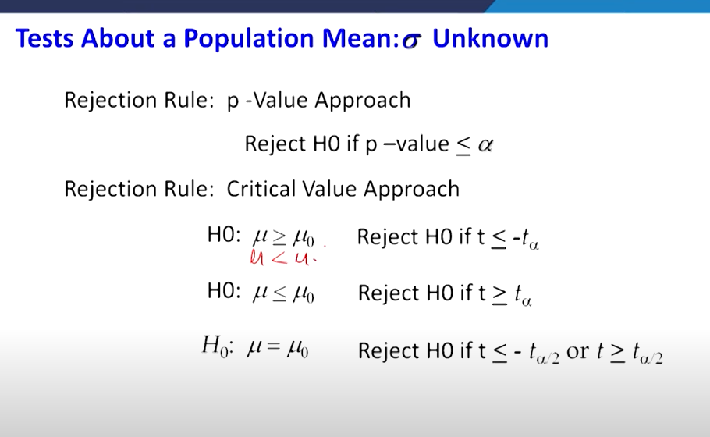

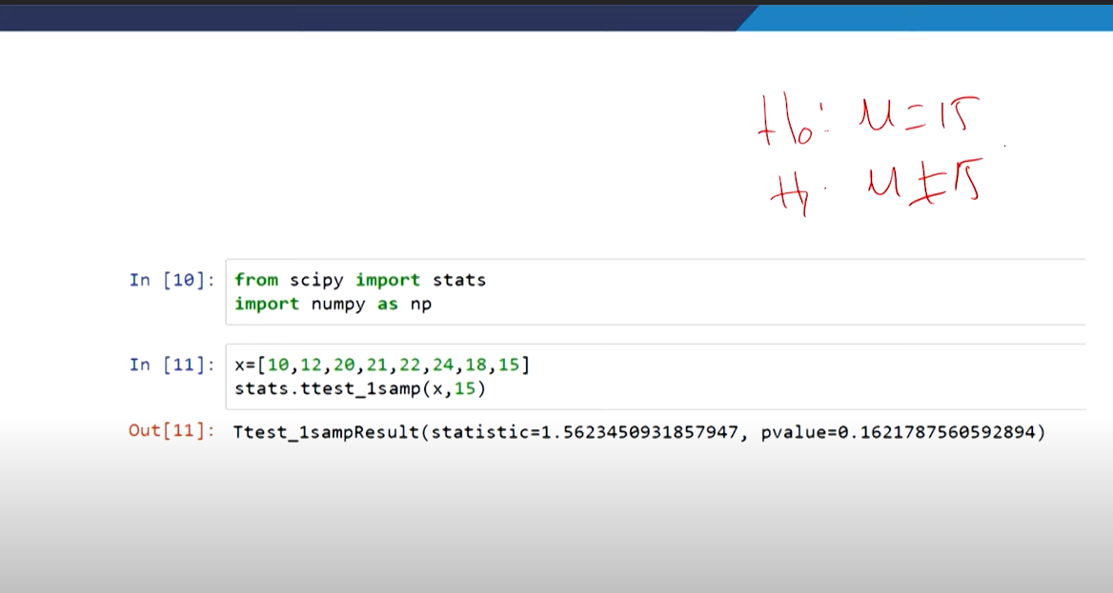

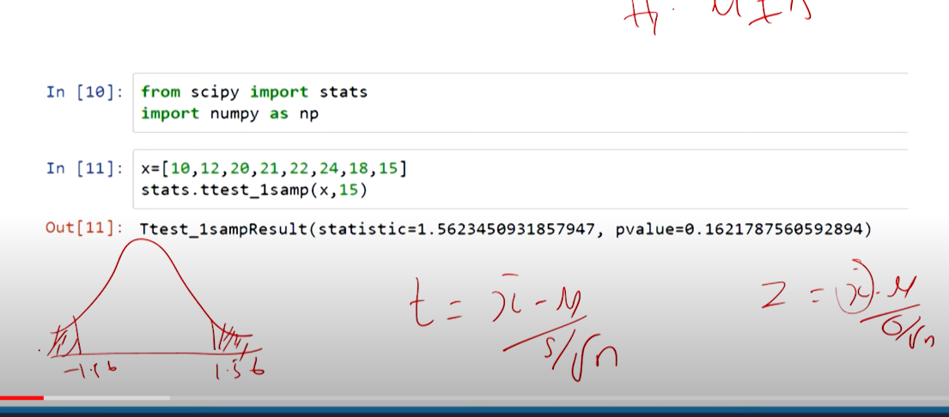

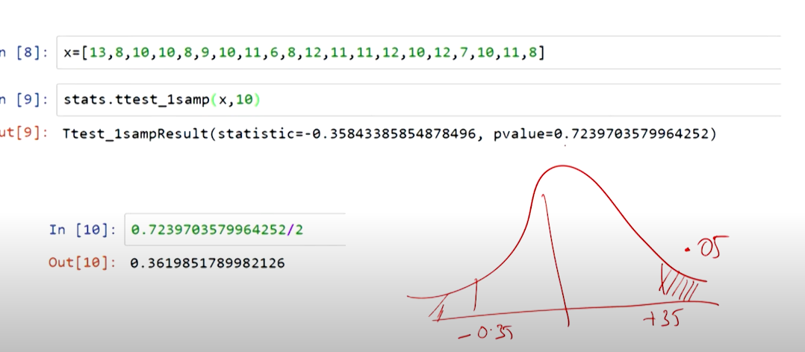

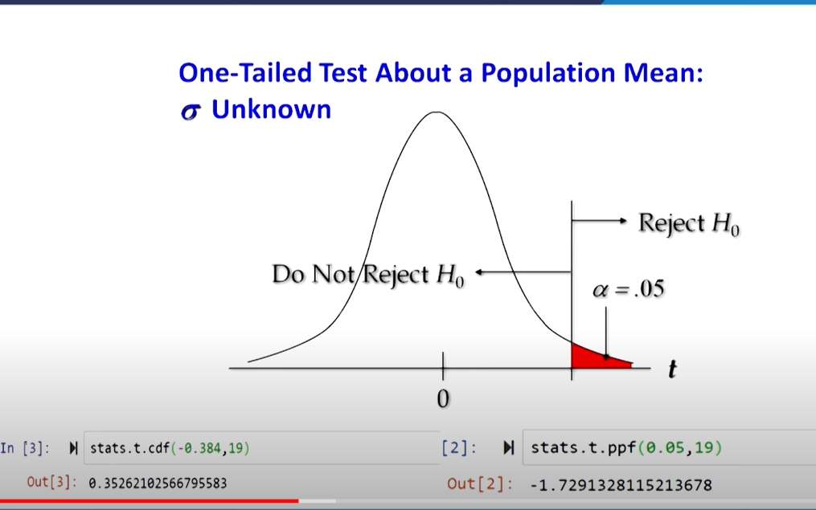

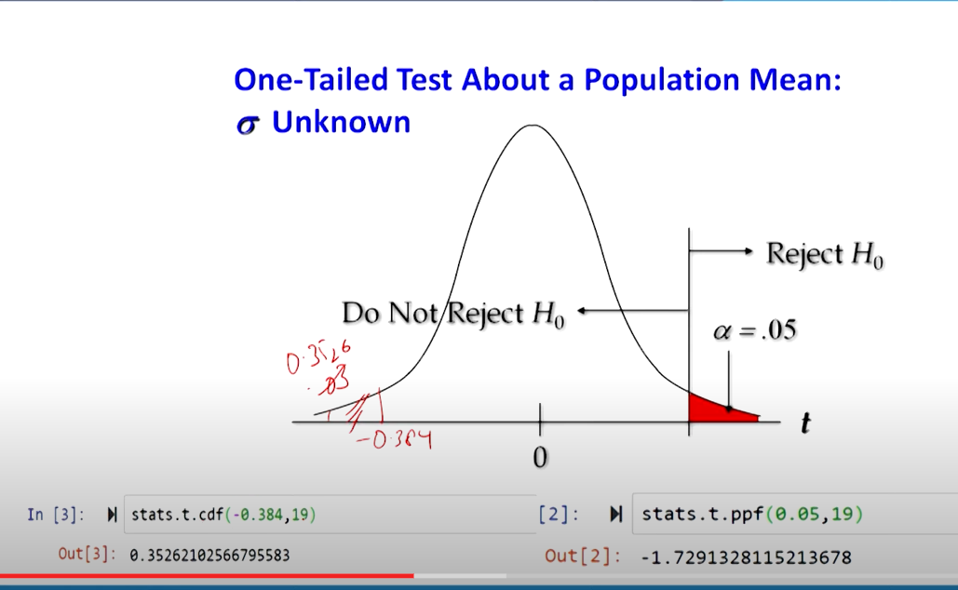

**0.384= t value**

**19 = degree of freedom**

